January 25, 2024

Applicability: Vogtle Units 3 & 4 RO’s

Internal Data Fixes: N/A

Internal Release:
B2024-004
In the RO Editor, fixed the issue for when Child values have a length of zero, the parent value will now be displayed (as gray text) in the Child field. Also, when generating a RO.FST file, it will use the Parent value when the Child value length is zero.

Generic External Release:
Parent/Child RO Editor
In the RO Editor, when Child values have a length of zero, the parent value will now be displayed (as gray text) in the Child field. Also, when generating a RO.FST file, it will use the Parent value when the Child value length is zero.

Plant Specific Information for Release Letter:

N/A - This was found during the data entry for a new PROMS customer. Volian currently has control over the ROs and will be providing customer with the RO information.

Testing Requirements:
Use local copy of Vogtle procedure data and RO data.
- Verify (and change if needed) that the RO Path to the for the ASS Alarms in the Main Control Room set is to the local copy of the RO database.

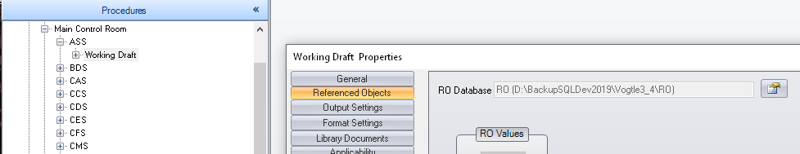
- Run the RO Edit

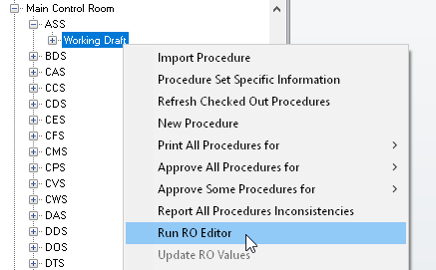

- Select Properties for the ASS ROs and open the Referenced Objects Definitions

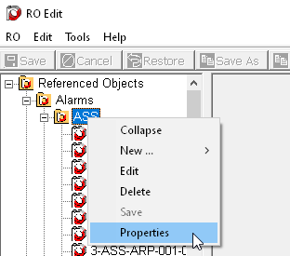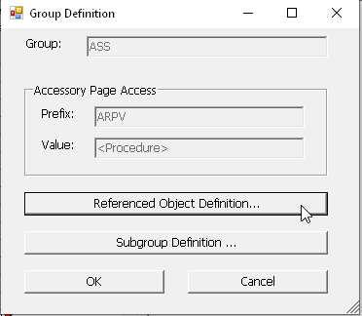

- Check the box next to Description then click on OK

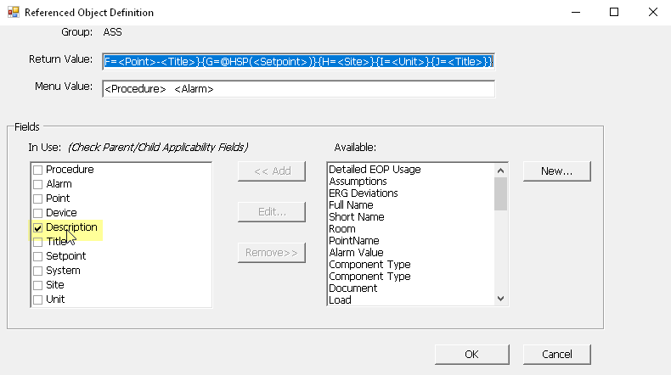

- Open the ASS-ARP-001-001 alarm and verify the child values under the Description field have the Parent Description in grey text.

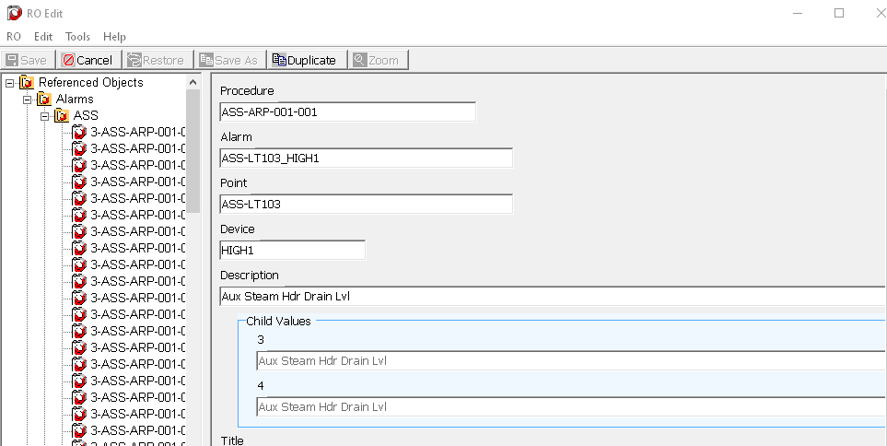

- Generate a new RO.FST then close the RO Editor
- Back in the PROMS Editor, update the ASS set with the new RO.FST.
- Print the first alarm point page in the ASS set (ASS-ARP-001-001)
- Verify the Description in the Alarm Point Table has the text as highlighted in the screenshot below:

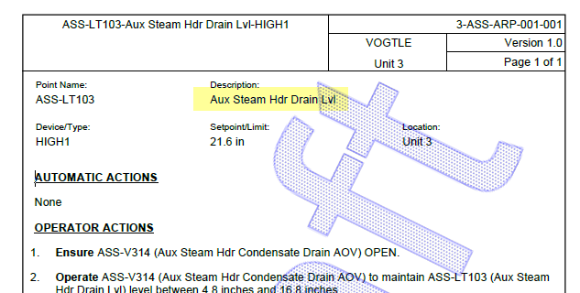

Changes/Additions to User Documentation:

N/A

