October 6, 2025

Applicability: GEN

Internal Release Information:
C2025-053 Upgrade Ro-Editor / Compare Report / Ro To SQL to 64 bits

Upgrade Ro-Editor / Compare Report / Ro To SQL to take advantage of extra memory allowed using 64 bits.

RO Editor version was upped to 2.4.

- [Check this box if a sql query or a data fix applies to this update].

Generic External Release:
Upgrade RO-Editor to take advantage of extra memory allowed using 64 bits.

Plant Specific Information for Release Letter:
N/A

Testing Requirements:
- Testing to do in RO Editor (With an Access RO database):
- Determine that RO-Editor is running as 64-bit: To determine if RO-Editor is running in 32 bit or 64-bit can run task manager while RO-Editor is running, go to details, and add columns as necessary:
x86=32 bit, x64 = 64 bit
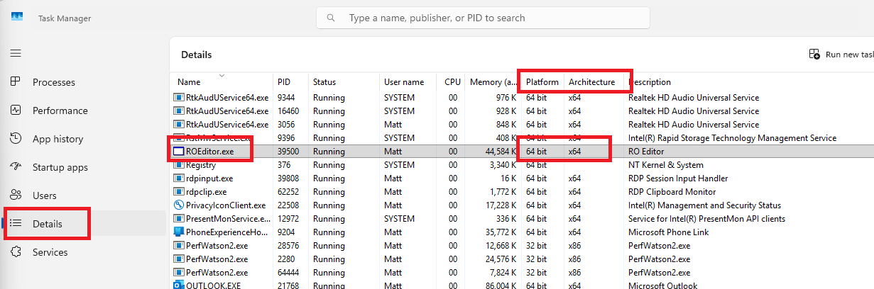
- Test can edit / add / save items in RO Editor
- Test Exporting a RO.FST (Create RO.FST)

- Testing to do in PROMS:
- Test VlnStatus still works: Run a RO Complete Report
- Test that RO Editor opens from PROMS via “Run RO Editor” context menu from Working Draft or button on Administrative tab
- Test that RO.FST imports and does not error
- Test convert Access RO db to SQL. Follow the “PROMS ROs in SQL Whitepaper.doc”
Important steps of the whitepaper include:
- Run 1st part of ROBuild.sql – have to uncomment DBA FUNCTION section
- Be sure to change all references to VEPROMS_DB_RO to what name you want the DB to be
- Be sure to change all references to “C:\Program Files\Microsoft SQL Server\MSSQL11.SQLEXPRESS_2012\MSSQL\DATA” to the location of your database mdf/ldf files
- Run the 2nd part of ROBuild.sql in the DB you just created
- Run ROFixes.sql in the DB you just created and se the switch to /RoInSql
- Go to Migrate to SQL in Properties off of a Working doc (be sure your RO db is pointing to a local copy – not the one on the server)
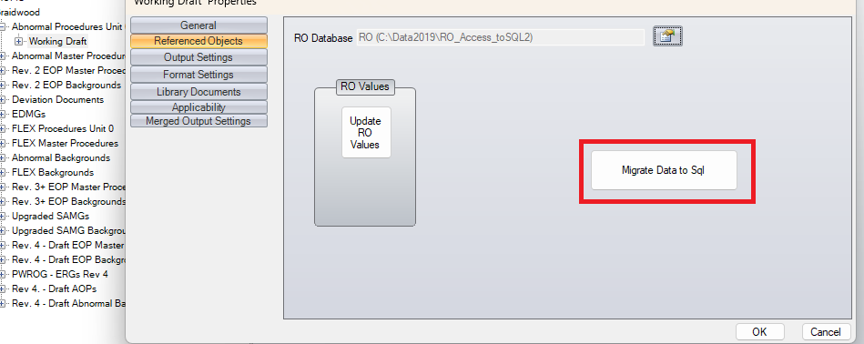
- Put in the name of the DB from (step A) above. Try Test Connect. When Successful then do Convert. Should have no errors.
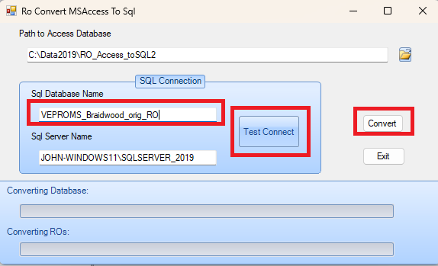

- Testing to do in RO Editor (With a SQL RO database):
- Determine that RO-Editor is running as 64-bit: To determine if RO-Editor is running in 32 bit or 64-bit can run task manager while RO-Editor is running, go to details, and add columns as necessary:
x86=32 bit, x64 = 64 bit
- Test can edit / add / save items in RO Editor

- Test Update RO Values

- Verify that the RO Editor version has been upped from 2.3 to 2.4.

Determine that RO-Editor is running as 64-bit: To determine if RO-Editor is running in 32 bit or 64-bit c

Changes/Additions to PROMS Manual and Training Videos:
[Do not use this section – for MRV/DMJ use]
- CSM submitted for PROMS User Manual: ____________.
- CSM submitted for training videos: ____________.

