July 3, 2024

Applicability: Beaver Valley

Internal Release Information:
F2024-065
Turned off the CapRoIfLastLower flag in all of the Beaver Valley formats so that RO values are not automatically be uppercased if the preceding text is uppercased and the text after is lowercase or there isn't text after it.

F2024-066
Turned off the Replace Words feature in the EOP Background the “without Issue Number” background, and the SAMG Background formats.

- [Check this box if a sql query or a data fix applies to this update].

Generic External Release:
N/A

Plant Specific Information for Release Letter:
Beaver Valley
RO values will no longer be automatically uppercased when they follow uppercase text and are preceded by uppercase text or not preceded by any text. RO values that are after a Dash Space (- ) will still be uppercased. This change was made to all of the Beaver Vallery formats.

Logical words will no longer automatically be underlined in the following Background formats:
- "Beaver Valley EOP Background Format"
- "Beaver Valley Background Format without Issue Number"
- "Beaver Valley SAMG Background Format"

Testing Requirements:
Use Beaver Valley data
- Update formats
- Open E-0 in the Unit 1 EOP procedure set and go to step 4
- Verify the RO’s that follow a dash are still uppercased in the RNO column

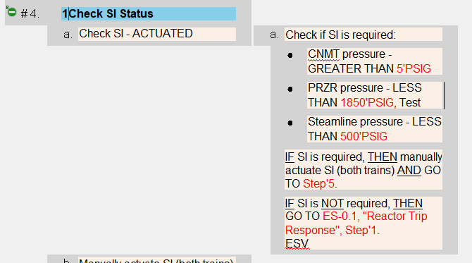

- Remove one of the dashes and verify the RO is lowercased

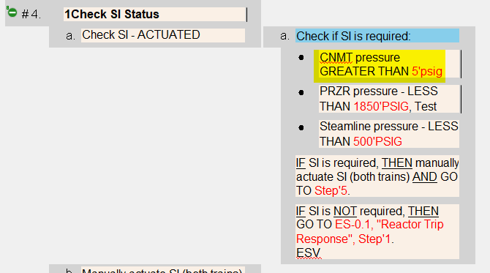

- Open SAG-5 in the unit one set and goto step 3.
- Verify the RO’s are not uppercased.

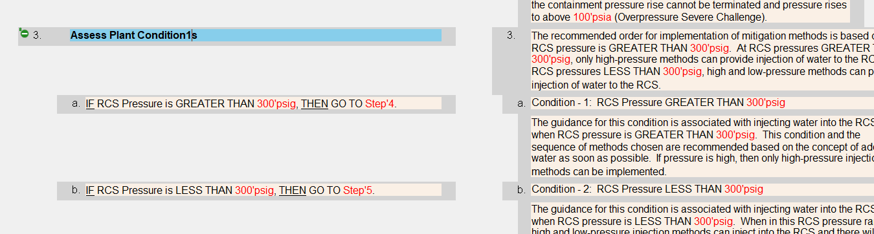

- Open an EOP Background document to the background of a step.
- Type ‘IF’ in all uppercase in basis text and move off the edit window.
- Verify the ‘IF’ is not underlined

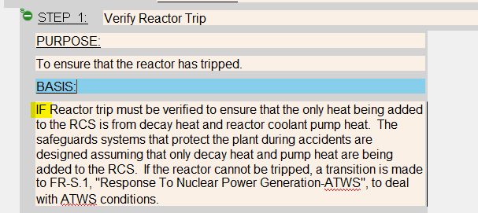

- Do the same in a NFPA Background
- Do the same in a SAMG Background

Changes/Additions to PROMS Manual and Training Videos:
No changes needed.

- CSM submitted for PROMS User Manual: ____________.
- CSM submitted for training videos: ____________.

