March 6, 2025

Applicability: Ginna

Internal Release Information:
F2025-004
Customer requested the addition of a Two Column Attachment section type

- [Check this box if a sql query or a data fix applies to this update].

Generic External Release:
N/A

Plant Specific Information for Release Letter:
Ginna
A Two Column Attachment section type was added to the Ginna EOP/AOP Format. The attachment number and title is printed in the page header box, the page number in the header box starts at one, column header are printed, step continue messages will appear when needed, and an END message is printed on the last page of the attachment.

Testing Requirements:
Use Ginna data
- Update formats
- Add a Two Column Attachment section to AOP procedure AP-RCS.5.
- Add some steps to it then print, including a long step that spans a two pages
Verify for this attachment section:
- The attachment number and title are in the header box
- The page number in the header box start at one
- There are column headers on the page
- The long step had continued messages
- There is an END message on the last page of the section

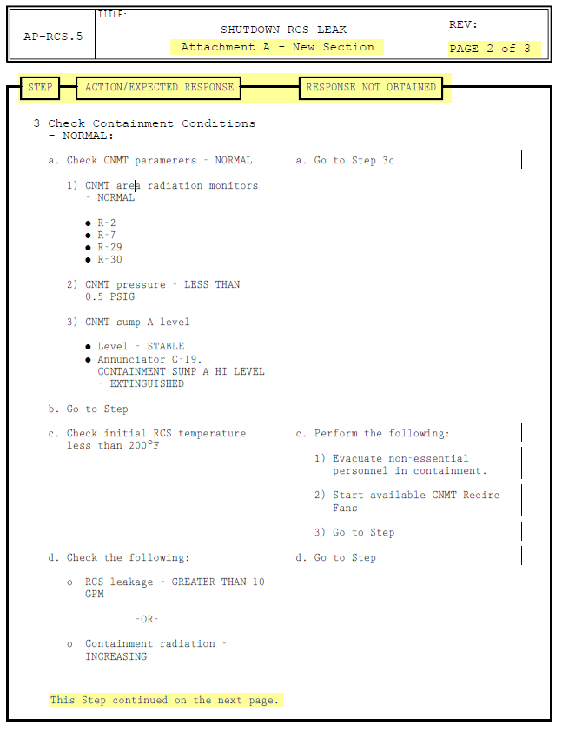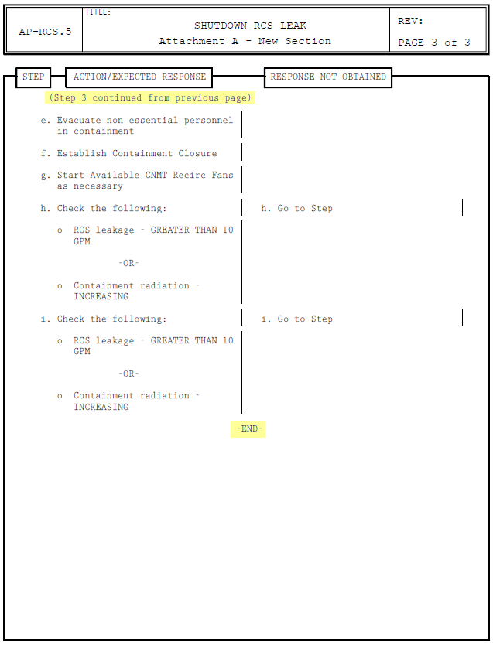

Changes/Additions to PROMS Manual and Training Videos:
[Do not use this section – for MRV/DMJ use]
- CSM submitted for PROMS User Manual: ____________.
- CSM submitted for training videos: ____________.

