September 16, 2024

Applicability: All Plants

Internal Release Information:
B2024-070
B2024-072
Correct typos in ancillary text.

- "Sort by Setpoint ID", select the Tools Toolbar -> Reports -> and under the Referenced Objects header select either Complete or Summary.

- "Select Category of Transitions", select the Tools Toolbar -> Search -> Transitions

Note that manual will also need updated screenshots to reflect these changes.

- [Check this box if a sql query or a data fix applies to this update].

Generic External Release:
Clarified wording in PROMS related to sorting reports by Setpoint ID, and selecting categories of transitions when searching transitions.

Plant Specific Information for Release Letter:
N/A

Testing Requirements:
- Use any plants database
- Select the Tools Toolbar -> Reports -> and under the Referenced Objects header select either Complete or Summary.
- Wording should read “Sort by Setpoint ID”
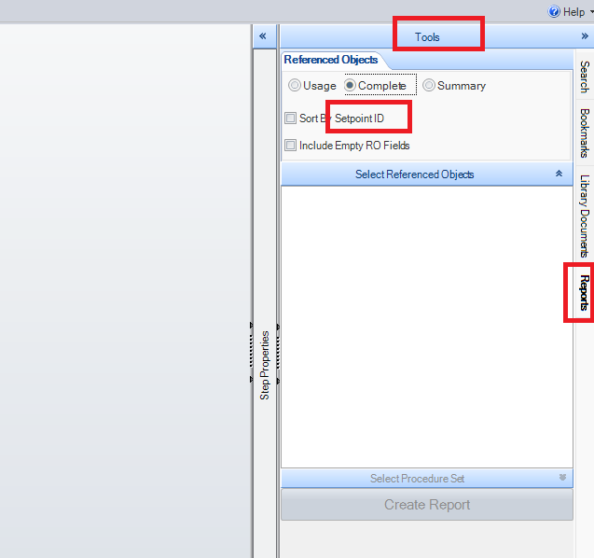

- Select any procedure, then Select the Tools Toolbar -> Search -> Transitions
- Wording should read “Select Category of Transitions”
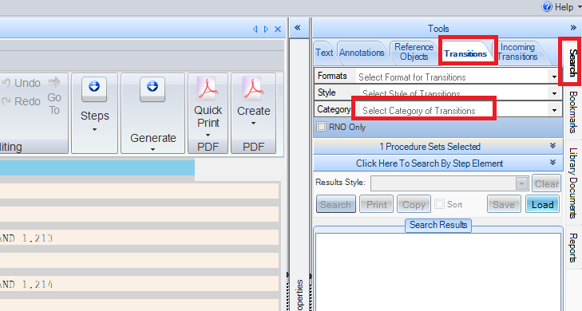

Changes/Additions to PROMS Manual and Training Videos:
[Do not use this section – for MRV/DMJ use]
- CSM submitted for PROMS User Manual: ____________.
- CSM submitted for training videos: ____________.

