May 22, 2025

Applicability: Barakah

Internal Release Information:
F2024-089
Barakah requested a newly formatted Cover page section style to make room for new Corporate Logo. The new logo will be placed at the top/left of the page and will sit outside the big box that is drawn on the page.

- [Check this box if a sql query or a data fix applies to this update].

Generic External Release:
N/A

Plant Specific Information for Release Letter:
Barakah formats
- The Cover Page section style was modified to allow for the new Corporate Logo, per examples provided by customer.
- The Procedure Specific Information form was updated to include Child Specific information for the Cover Pages, so that one Cover Page section could be used for all Child procedures. This was done only for the formats that are used in Parent/Child procedure sets.

Testing Requirements:
Use Barakah data
- Update Formats
- Print Local Alarm procedure [1N2]-OP-ARP-AS-0002 for unit 1
- Verify that their old logo prints outside the big box on the cover page

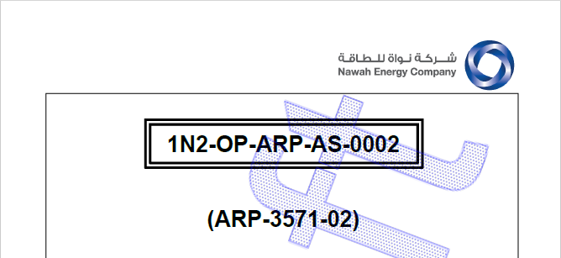

- Print and verify the same for an EOP, AOP, Background
- Print and verify the same for a Parent/Child procedure that uses the Single Column format such as an IOP, print for Unit 1 and then one of the other three units.
- For the same Parent/Child procedure, open the Procedure Specific Information add Child information for one of the other units

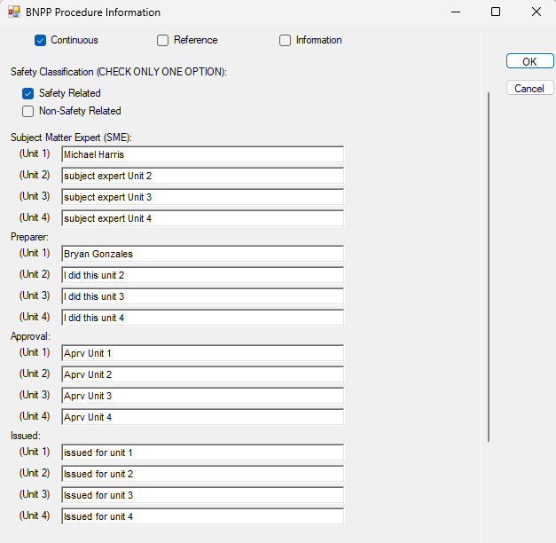

- Change the Applicability on the first Cover Page section to be applicable to all children (units) and set the other cover pages applicability to none

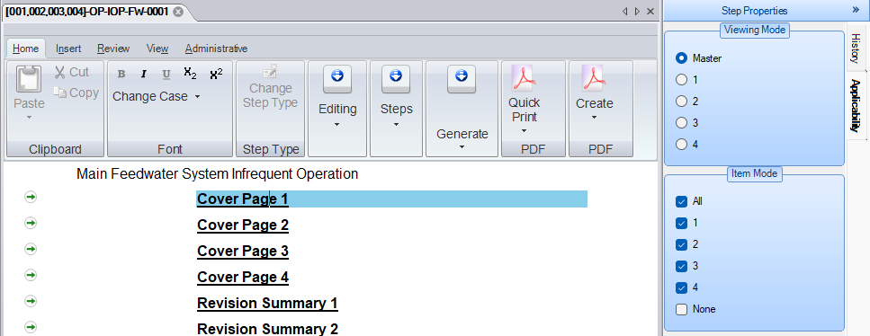

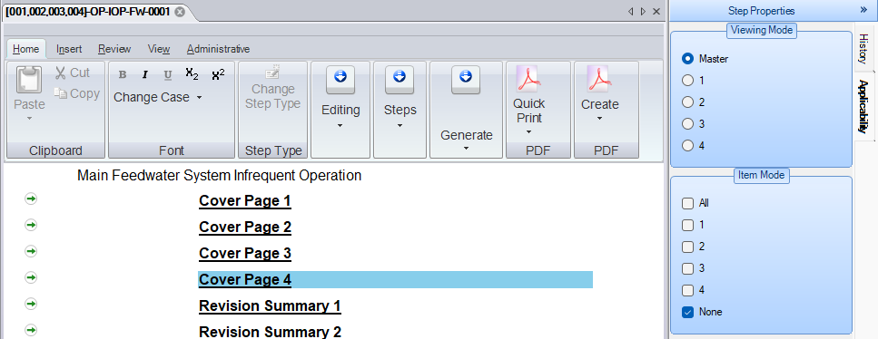

- Print the procedure for each child and verify the correct child information appears on the cover page

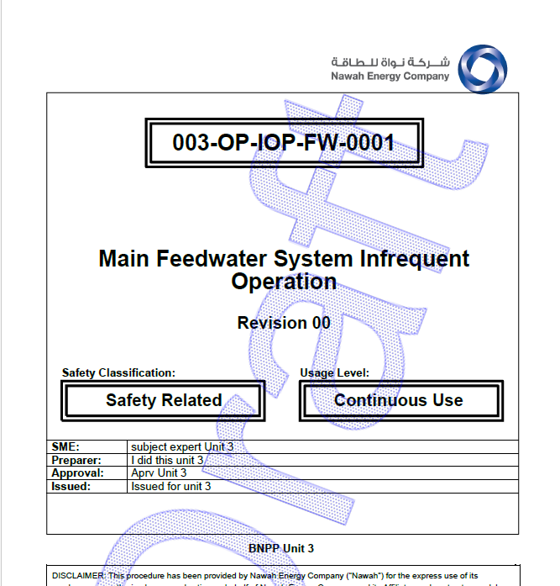

Changes/Additions to PROMS Manual and Training Videos:
[Do not use this section – for MRV/DMJ use]
- CSM submitted for PROMS User Manual: ____________.
- CSM submitted for training videos: ____________.

