10/19/2023

Applicability: B2023-103: Incoming transitions improve user interface

Internal Data Fixes: NA

Internal Release:

B2023-103: Incoming transitions improve user interface. Note that one of the issues fixed was that the confirmation dialog for converting transitions to text was displayed twice. This occurred because there was duplicate code in the designer that attached an event to the Convert button for processing. This code was removed, in DisplaySearch.designer.cs.

Generic External Release:

When converting Incoming Transitions to Text, if some were not converted the Message Box for confirming will no longer display twice. Also, a wait cursor is now displayed when doing the search for and convert to text of Incoming Transitions.

Plant Specific Information for Release Letter: NA

Testing Performed:

See Testing Required.

Testing Requirements:

Using the Farley sql database:
£ From the tree view, select Incoming Transitions for Rev 3 Unit 1 ERPs/EPP-0
£ Verify that a spinner (wait cursor) displays until the Search Results list is filled in
£ Select Convert All to Text, select Yes on the confirmation dialog and verify that a spinner (wait cursor) displays until a dialog is displayed that informs the user that the Admin Tools/Links/Refresh Transitions clears the list.

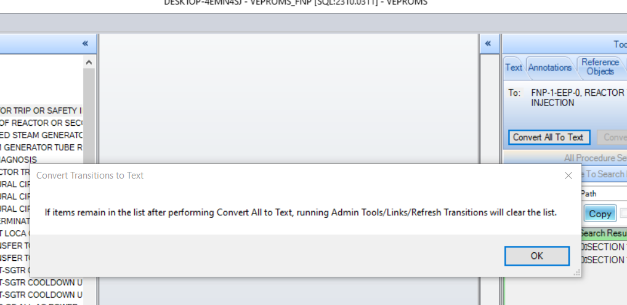

£ Also verify that the confirmation dialog to convert transitions is not displayed twice

Changes/Additions to User Documentation:

If user documentation contains details of Incoming Transition/Convert All to Text functioning, add the above dialog to that documentation.

