July 31, 2025

Applicability: All plants

Internal Release Information:
C2025-046
Make text changes to the Filter Annotations feature.
SQL updates included.

Generic External Release:
Users now can select a list of annotation types to display from the whole annotation types list. The filtering is applied on the User level by going to the “Options” window within the V prompt and selecting the “Open” button on the “Filter Annotation Types” widget.

Plant Specific Information for Release Letter:
N/A

Testing Requirements:
- USE DB VEPROMS_BWD
- Open the options in the V menu.
- Review that the requested text changes were made.

On the System Options window:
- Verify the widget title has been changed to "Filter Annotation Types".
- Verify that the name of the button on the widget has been changed to "Open".
- Verify that there is only one button at the bottom of the Options window and the label of the button is “Ok”.

In the “Filter Annotation Types” window.
- Verify that the two buttons in the lower right corner are labeled “Cancel” and “Save”.
- Verify when clicking the “Save” button that the window does not close.

In the left navigation tree.
- Verify that the “Select Annotations” link has been removed on the procedure level.

Images:

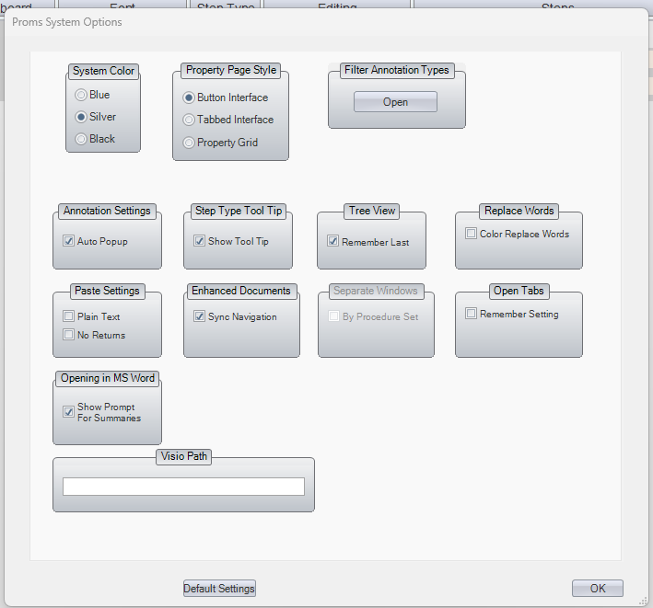

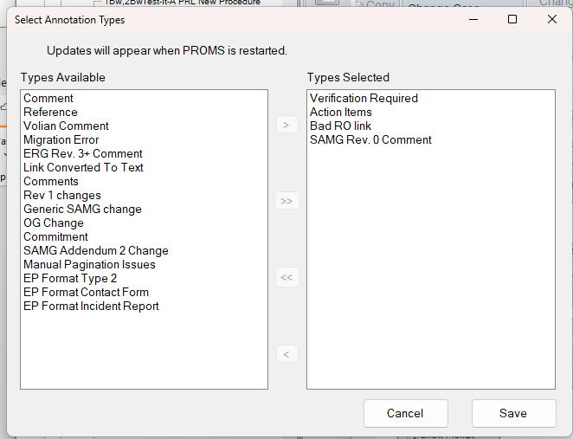

Changes/Additions to PROMS Manual and Training Videos:
[Do not use this section – for MRV/DMJ use]
- CSM submitted for PROMS User Manual: ____________.
- CSM submitted for training videos: ____________.

