May 19, 2025

Applicability: BVPS

Internal Release Information:
C2025-013 Option to Disable “Message Prompt when a Summary will open in MS Word”

When generating a Continuous Action Summary/Time Critical Action Summary, users receive a message:

The _______Summary will be opened in MS Word.
You can make modifications and copy it into a PROMS Word section

This will now contain a checkbox to disable future messages related to this. Also, there will be an option added to the V -> PROMS options for turning this on/off in case someone later wants the message back.

- [Check this box if a sql query or a data fix applies to this update].

Generic External Release:
Added an option to disable the message prompt when a Continuous Action Summary/Time Critical Action Summary will open in MS Word. There will now be a checkbox on these messages to disable future display for the viewer. This setting can also be adjusted on the V->Options page.

Plant Specific Information for Release Letter:
Per Mike Kesow request at BVPS: Added an option to disable the message prompt when a Continuous Action Summary/Time Critical Action Summary will open in MS Word. There will now be a checkbox on these messages to disable future display for the viewer. This setting can also be adjusted on the V->Options page.

Testing Requirements:
- Use any plants database – was requested by BVPS
- Generating a Critical Action Summary or Time Critical Action Summary – message should contain a checkbox that disables future runs from having the message prompt:
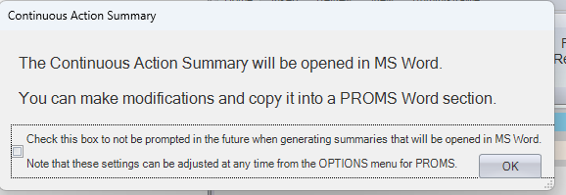
- Setting can also be updated via V-> Options:
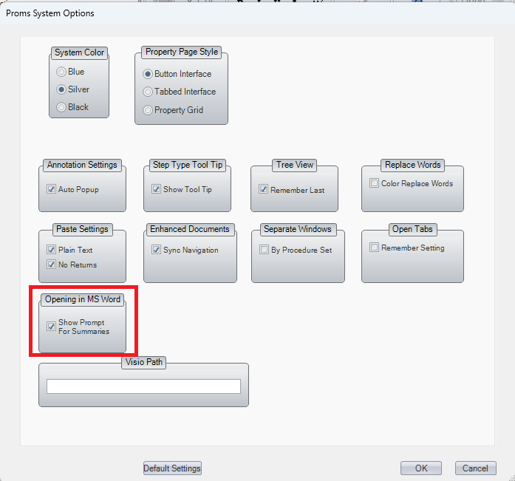

Changes/Additions to PROMS Manual and Training Videos:
[Do not use this section – for MRV/DMJ use]
- CSM submitted for PROMS User Manual: ____________.
- CSM submitted for training videos: ____________.

