October 20, 2025

Applicability: GEN

Internal Release Information:

C2024-047 Redesign PROMS Security Dialog

Redesign the PROMS Security dialog to make it more user-friendly to use and to see each PROMS user’s security credentials.

- [Check this box if a sql query or a data fix applies to this update].

Generic External Release:
Redesigned the PROMS Security dialog to make it more user-friendly to use and to see each PROMS user’s security credentials.

Plant Specific Information for Release Letter:
N/A

Testing Requirements:
- Use Any DB – pick a user with administrative rights
- Go to Manage Security:
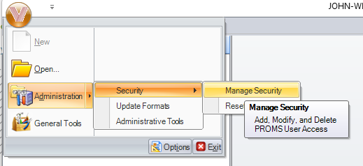
- By Default, Should Open to the “Manage Users Tab”
- Selecting a User should show the Groups the User is a member of (in the left list box)
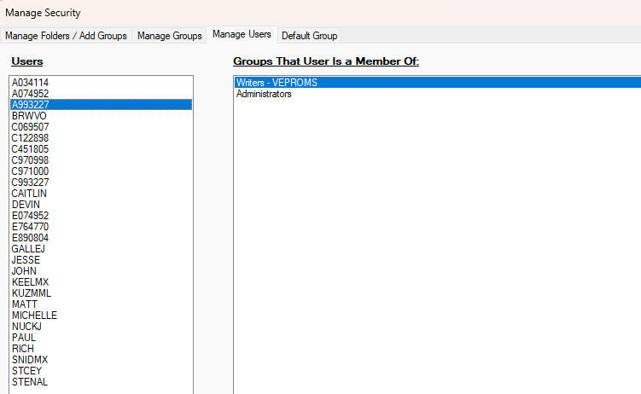
- Right Clicking in the Group box (not on a Group) should give options to add the User to each group they are not a member of:
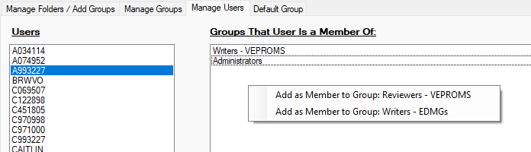

- Selecting each option should add them as a member of that group
- Right Clicking in the Group box (on a Group) Should give the option to Remove the User From that group
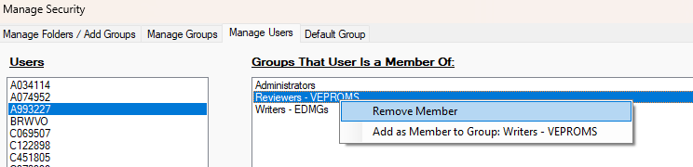
- It will prompt regarding confirmation:
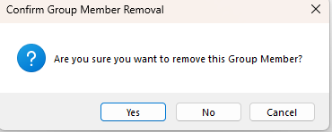
- Right Clicking in the User box (not on a User) should give the option to add a User
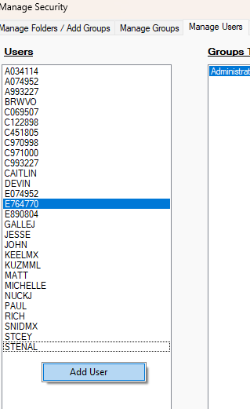
- Right Clicking in the User box (on a User) should give the options to add a User, edit a User, or delete a User
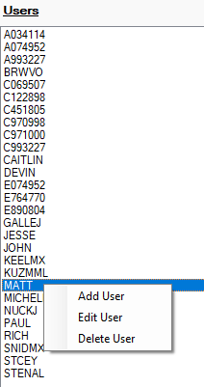
- Adding the User, should add a User and make them a member of the Default Group (Tab 4 at the top) – it should also refresh the Users list to include the new User
- Editing a User – if you change the UserID for a User and click save, the Users list should auto update to reflect the new UserID.
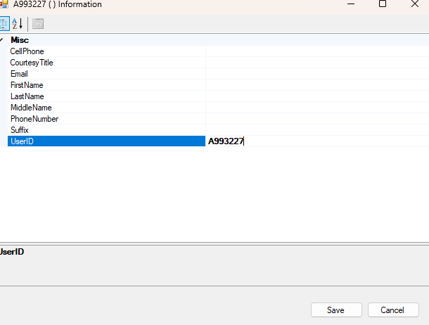
- Deleting a User will prompt for confirmation and delete the User from any groups they are a member of.
  - If a member of any group:
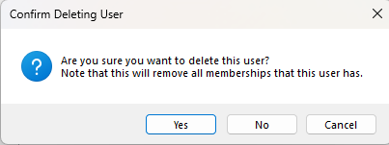
  - If not a member of any group:
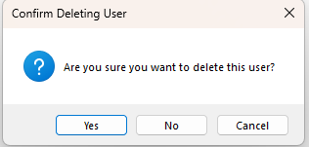

- Manage Folders / Add Groups will behave as it previously did (whereby right clicking on a folder gives options for creating a group. If a group is selected that already exists, then nothing will happen (it will just keep the pre-existing group).)
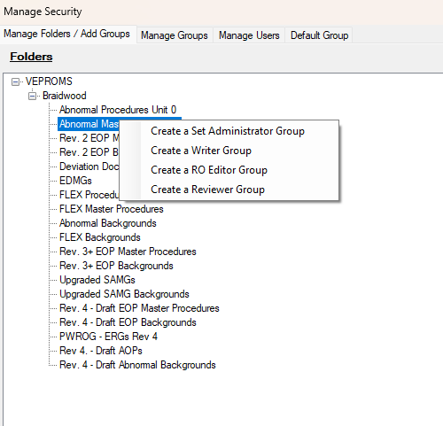
- After adding a new group on the “Manage Folders/Add Groups” tab change to the “Default Group” tab to ensure that the new group appears there. (ensures no caching issue)
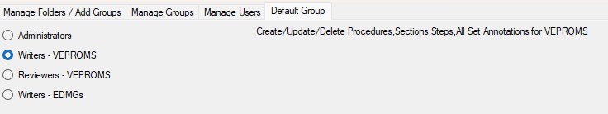
- After adding a new group on the “Manage Folders/Add Groups” tab change to the “Manage Groups” tab to ensure that the new group appears there. (ensures no caching issue)
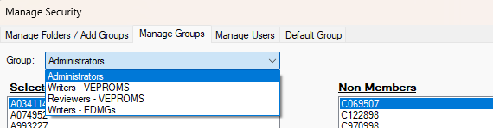
- After adding a new group on the “Manage Folders/Add Groups” tab change to the “Manage Users” tab and Select a User then right click in its groups to ensure that the new group appears there. (ensures no caching issue)
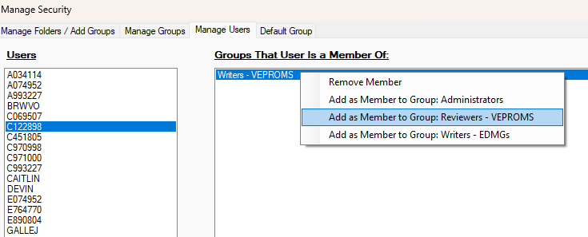
- the “Manage Groups” tab – selecting a group should show the Users that are a member of the group and are not a member of the group.
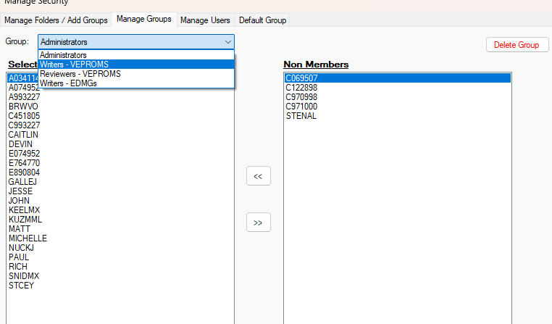
- Arrow buttons in between the lists should add a User as a member of a group (or remove them as a member of the group). Removing a member from a group will give a confirmation prompt.
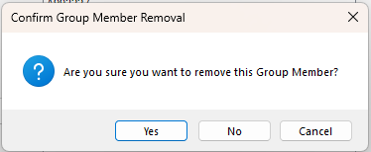
- Delete Group Should delete the group selected in the dropdown.
  - It will not allow the group to be deleted if it has any members
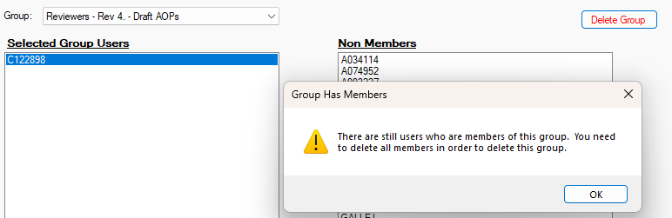
  - It will not allow the group to be deleted if it is the default group in the “Default Group” tab
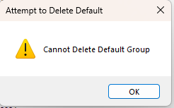
  - Deleting a group will give a confirmation prompt.
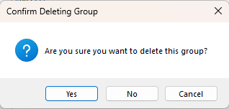
- When a group is deleted via the “Manage Groups” tab, then the “Default Group” tab will update to reflect the removed group
- When a group is deleted via the “Manage Groups” tab, then the “Manage Users” tab will update to reflect the removed group (Right clicking in the Groups that a User is a member of box)
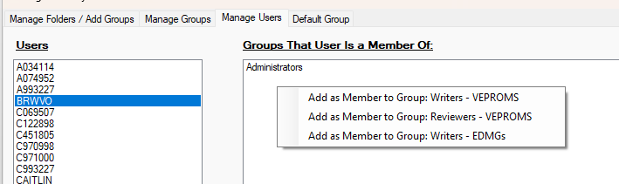

Changes/Additions to PROMS Manual and Training Videos:
[Do not use this section – for MRV/DMJ use]
- CSM submitted for PROMS User Manual: ____________.
- CSM submitted for training videos: ____________.

