6/25/2024

Applicability: All Plants

Internal Release Information:
C2024-013
On the Print dialog, when the Create RO and Transition Hyperlinks button is ON, disable the Merge PDFs button. The Create RO and Transition Hyperlinks option looks for individual file names for the procedures to go to.

- [Check this box if a sql query or a data fix applies to this update].

Generic External Release:
On the Print dialog, when the Create RO and Transition Hyperlinks button is ON, the Merge PDFs button will now become disabled. This occurs because the Create RO and Transition Hyperlinks option looks for individual file names for the procedures to go to and separate procedure files are not created when the files are merged, thus making the links invalid.

Plant Specific Information for Release Letter:
N/A

Testing Requirements:
Using any sql database, such as Braidwood:
- Open a folder, such as Abnormal Procedures Unit 0, position on Working Draft.
- Using the context menu from Working Draft, select to Print All Procedures
- From the Print Dialog, Turn ON the Create RO and Transition Hyperlinks to verify that the Merge PDF button becomes disabled:
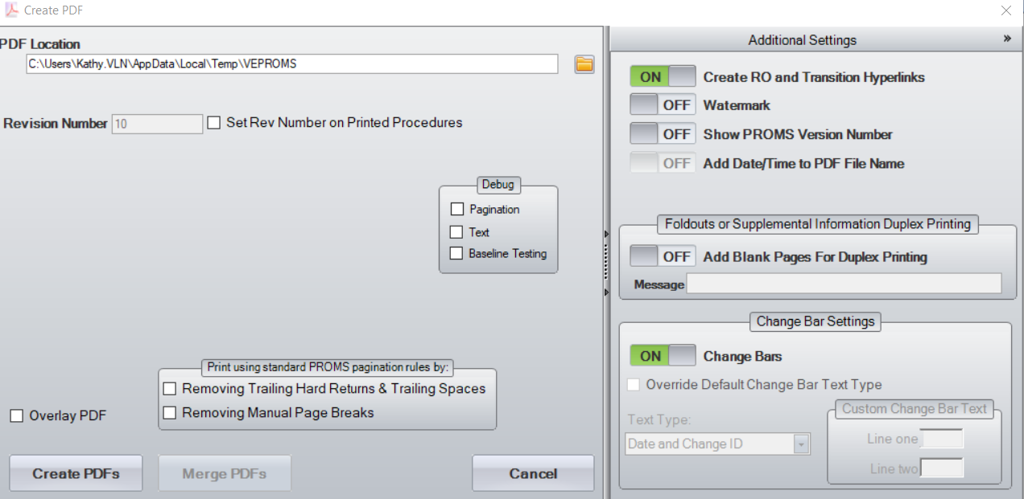
- Turn OFF the Create RO and Transition Hyperlinks to verify that the Merge PDF button becomes enabled:
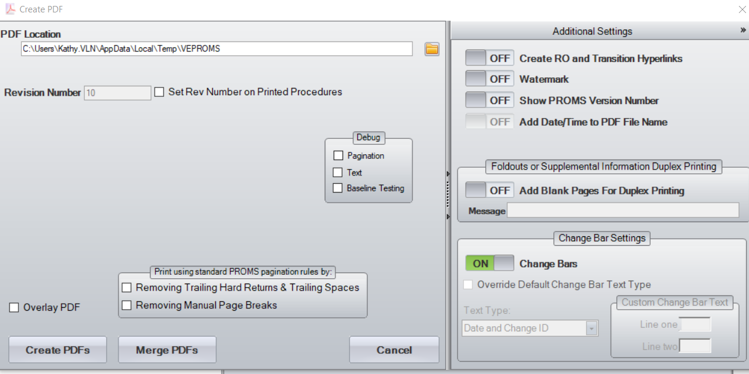

Changes/Additions to PROMS Manual and Training Videos:
- CSM submitted for PROMS User Manual: ____________.
- CSM submitted for training videos: ____________.

For the Print dialog, if the user manual or training videos discuss the On/Off button for Create RO and Transition Hyperlinks, add information that the MergePDFs button is not available for print/merge of all procedures in a Set since the hyperlink go to separate procedure files which are not available for a merge.

