June 5, 2024

Applicability: Beaver Valley

Internal Release Information:
F2024-063
Beaver Valley requested that the section number be underlined at the top of the pages of the Two Column Attachment section style in the “Beaver Valley Single Column Format with Issue Number” (BVSP1). Also, an extra space was added between the top continue message and first line of step text on that page.

- [Check this box if a sql query or a data fix applies to this update].

Generic External Release:

N/A

Plant Specific Information for Release Letter:
Beaver Valley
Beaver Valley Single Column Format with Issue Number
- The Two Column Attachment section style will now underline the section title and extra space was added between the top continue message and the first line of step text.

Testing Requirements:
Use Beaver Valley data
- Update formats
- Change the section style of Attachment 11 for procedure SD-1 in the Unit 2 procedure set in the SD EOPs folder to “Two Column Attachment”

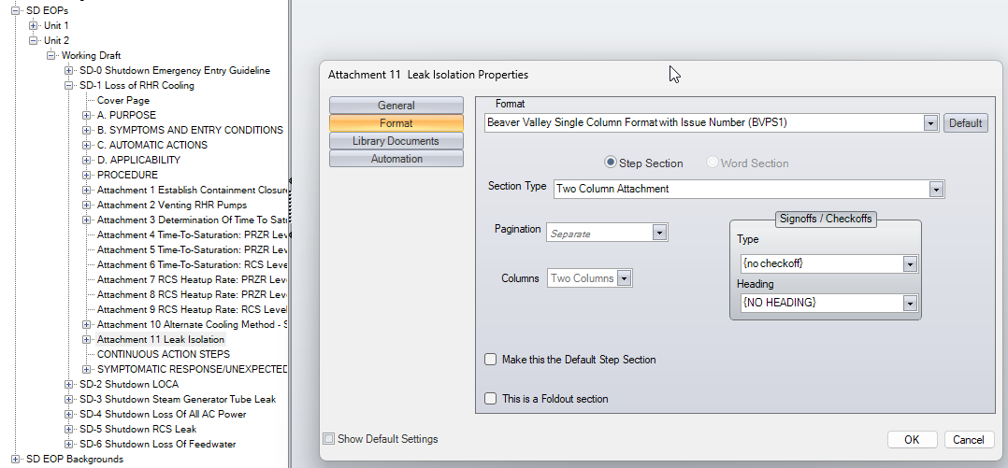

- Print the section and verify the section number is underlined and there is extra space between the top continued message and the first line procedure text.

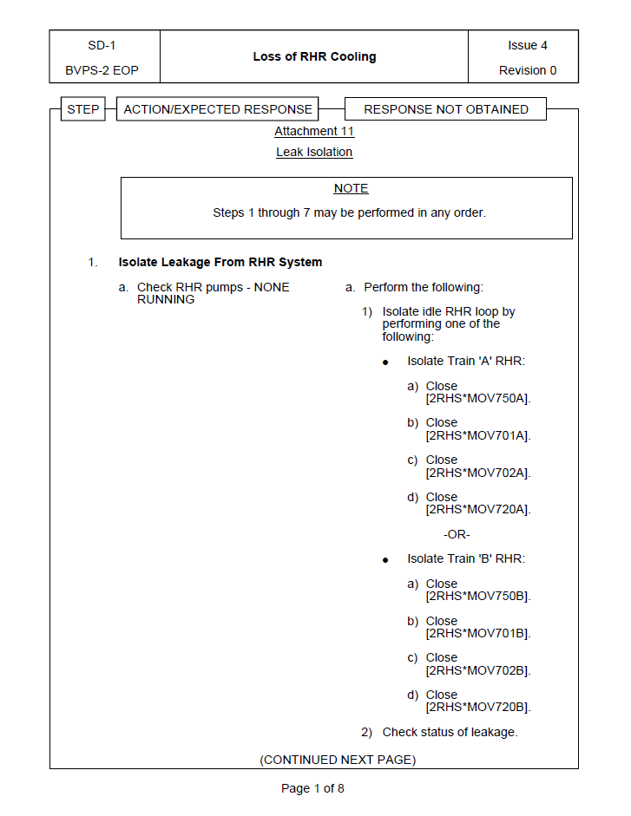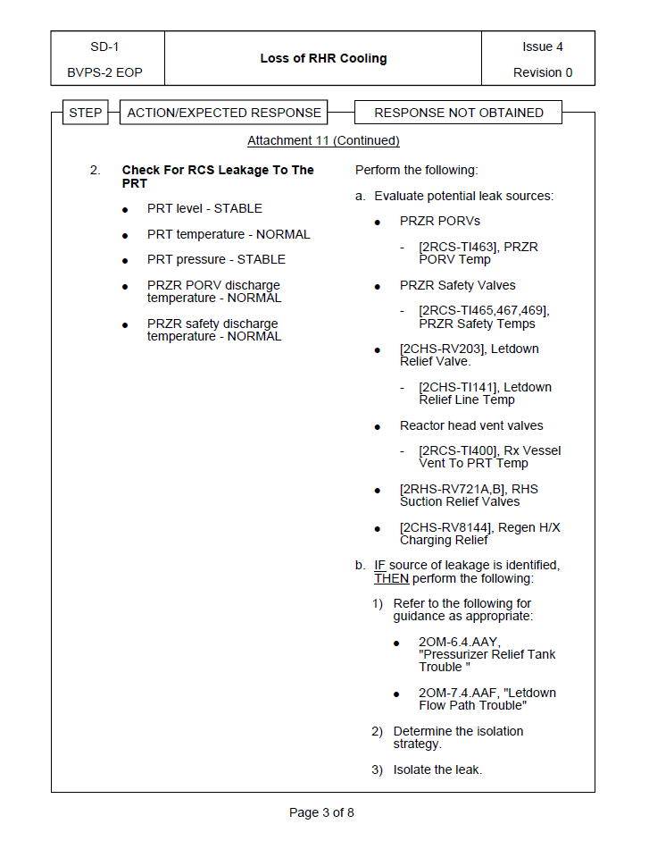

Changes/Additions to PROMS Manual and Training Videos:

No changes needed for the user manual nor the training videos

- CSM submitted for PROMS User Manual: ____________.
- CSM submitted for training videos: ____________.

