December 11, 2024

Applicability: All Plants

Internal Release Information:
B2024-094 Carats (as Deltas) print as question marks in tables when unit <u> is used in RO Definition Value.
When carets are entered into an RO that has <u> as part of the RO Value and the RO is used in table cell, they print as question marks. This was found using Braidwood's data and Alarm Equipment ROs.

(Testing of B2024-003, B2024-093, B2023-113 was being performed when this was found)

- [Check this box if a sql query or a data fix applies to this update].

Generic External Release:
Improved user experience when working with ROs containing a caret that should print as a Delta and different unit designations.

Plant Specific Information for Release Letter:
N/A

Testing Requirements:
- Utilize an RO that has the <u> in the Return Value and add carats in the field that would be returned. A good example is in Braidwood Equipment Alarms, for example:
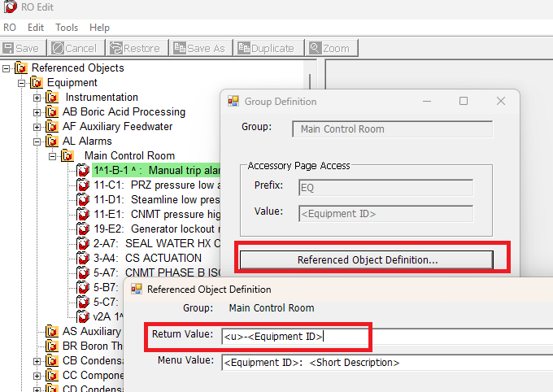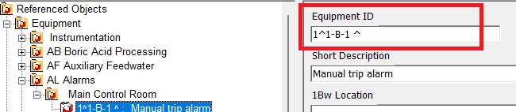
- Insert an AER table into a PROMS step section.
- Insert the RO into a table cell.
- Open the RO Editor and modify the RO that's in the table cell adding a caret and/or dash into the RO value.
- Create an RO.FST and update RO Values.
Should test that carat shows properly in Print. (The caret character would previously show properly in the edit window, but would Print as question marks)
- Should perform the same test as above but utilizing a Centered Table

Example of a unit one print:
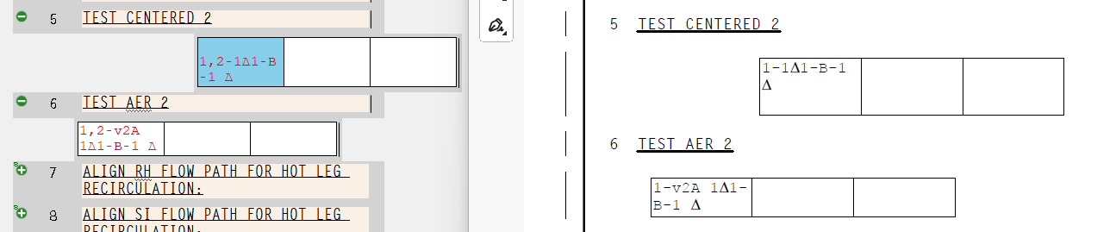

Changes/Additions to PROMS Manual and Training Videos:
[Do not use this section – for MRV/DMJ use]
- CSM submitted for PROMS User Manual: ____________.
- CSM submitted for training videos: ____________.

