July 1, 2026

Applicability: South Texas

Internal Release Information:
F2026_015
Moved the change bar position to the right one space to accommodate the wider Caution and Note boxes

- [Check this box if a sql query or a data fix applies to this update].

Generic External Release:
N/A

Plant Specific Information for Release Letter:
South Texas
Old and New EOP formats
- Move the change bar position to the right a little bit to accommodate the wider Caution and Note boxes

Testing Requirements:
Use South Texas data
- Update formats
- Print EOP procedure EO-ES01
- Verity the change bars on the Caution and Note of step 14 are visible

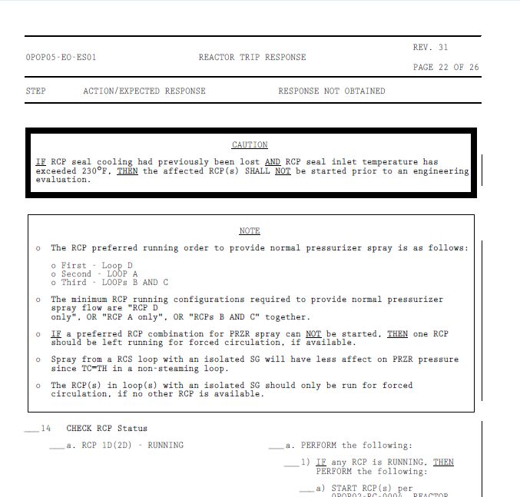

Changes/Additions to PROMS Manual and Training Videos:
[Do not use this section – for MRV/DMJ use]
- CSM submitted for PROMS User Manual: ____________.
- CSM submitted for training videos: ____________.

