December 3, 2025

Applicability: GEN

Internal Release Information:

B2019-140/B2022-099 After doing an Approval (final stage) of a procedure, the change bars do not reset on the screen.

Also, when change the “Showing Change bars” option, the screen does not refresh.

This was reported by Alex at BNPP.

- [Check this box if a sql query or a data fix applies to this update].

Generic External Release:
When doing an Approval (final stage) of a procedure, the Change Bars will now reset on the screen to reflect the new Change Bar date.

Plant Specific Information for Release Letter:
N/A – is generic but reported by Alex at BNPP.

Testing Requirements:
- Use Any DB
- Make Edits to a procedure to create change bars (or pick a procedure that already has change bars)
- Have no procedure open & Right click on the Procedure in the Tree and Select “Showing Change Bars Starting_______”
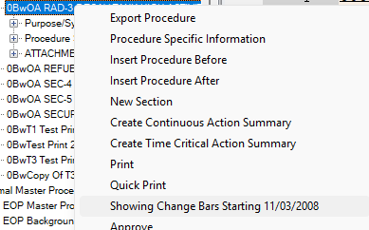

- If you right-click on the tree node again after changing it, it should update with the new date
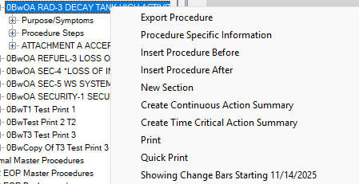

- Have the procedure open in an active tab & Right click on the Procedure in the Tree and Select “Showing Change Bars Starting_______”
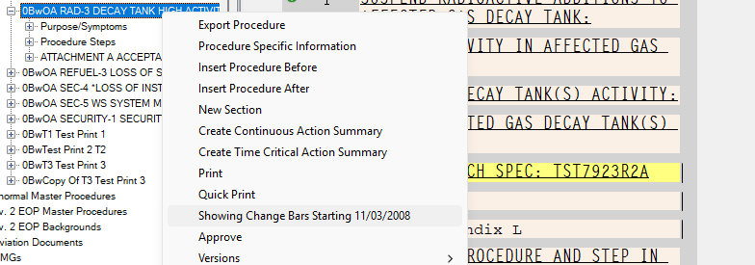
- In addition to changing the data when, right clicking on the tree node, the open procedure should refresh to show/hide change bars (should test both a recent date to remove them and an older date to add them in)
- Have the procedure open in a non-active tab (basically have more than 1 procedure open and change one of the ones that is not active) & Right click on the Procedure in the Tree and Select “Showing Change Bars Starting_______”
- When clicking on the procedure to make it active, it should reflect the new date set for the Change Bars.
- Use a Procedure that has change bars and at least 1 previous version (or create one).
- Generate as Approved & keep the same Revision Number.
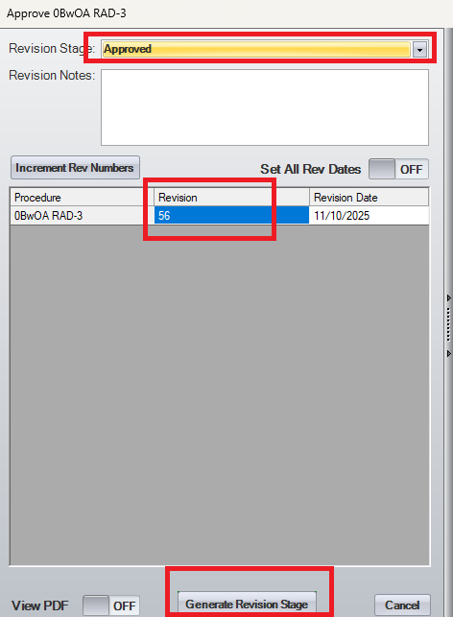

- Select Yes for the Summary of Changes and “OK” for replacing the existing revision.
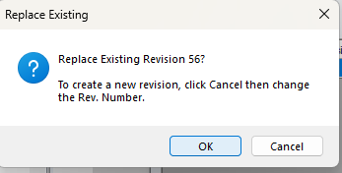
- Change Bars should be removed and right-clicking on the node in the tree should reflect the current date on the “Showing Change Bars Starting_______” option.

Changes/Additions to PROMS Manual and Training Videos:
[Do not use this section – for MRV/DMJ use]
- CSM submitted for PROMS User Manual: ____________.
- CSM submitted for training videos: ____________.

