December 9, 2024

Applicability: All Plants

Internal Release Information:
B2024-095 In Admin Tools, added minimum heights to the left side panels above selecting items in the trees. Previously when the windows were resized the trees would overlap with buttons and notes.

- [Check this box if a sql query or a data fix applies to this update].

Generic External Release:
Enhanced Admin Tools so that panel containing buttons has a minimum height to prevent text overlapping on the admin tools notes and buttons.

Plant Specific Information for Release Letter:
N/A

Testing Requirements:
- Use Any Plant
- Select the Admin Tools
- Navigate to the Links Page and then using the mouse try to resize the page. The tree selection should now only be able to move up so far and not overlap the notes.
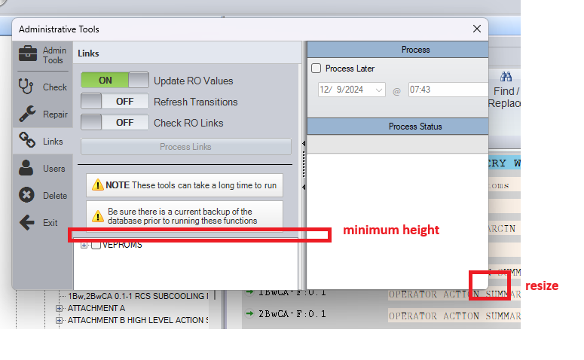
- Navigate to the Delete Page and then using the mouse try to resize the page. The tree selection should now only be able to move up so far and not overlap the notes.
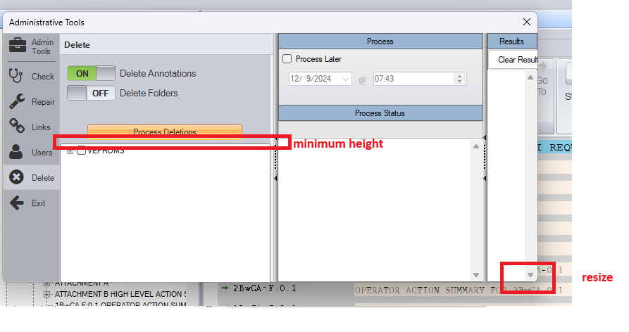

Changes/Additions to PROMS Manual and Training Videos:
[Do not use this section – for MRV/DMJ use]
- CSM submitted for PROMS User Manual: ____________.
- CSM submitted for training videos: ____________.

