March 25, 2026

Applicability: All Plants

Internal Release Information:
B2026-023 Add symbols to X_Y Plots in RO Editor and PROMS steps.

- [Check this box if a sql query or a data fix applies to this update].

Generic External Release:
Symbols can now be added to RO X/Y Plots in the RO Editor. Symbols can only be added to X, Y, Z, and B rows.

Plant Specific Information for Release Letter:
N/A

Testing Requirements:
Verify that symbols can be added into X/Y Plots in rows X, Y, Z, and B.

- Use Callaway DB
- Open RO Editor
- Find an X/Y Plot RO.
- Add symbols in any or all X, Y, Z, and B rows.
- Save and make sure that the symbols are saved correctly.
- Create RO.FST file.
- Exit RO editor.
- In PROMS open a procedure.
- Add a new figure word section to the procedure.
- From the RO tab in the Step Properties choose the RO X/Y Plot you modified and add it to the new section.
- Save the new section.
- Close section and right click the section name in the left tree view and select print.
- Verify that the symbols are printed correctly in the printout.
- Repeat above steps with another RO if necessary.

Image:
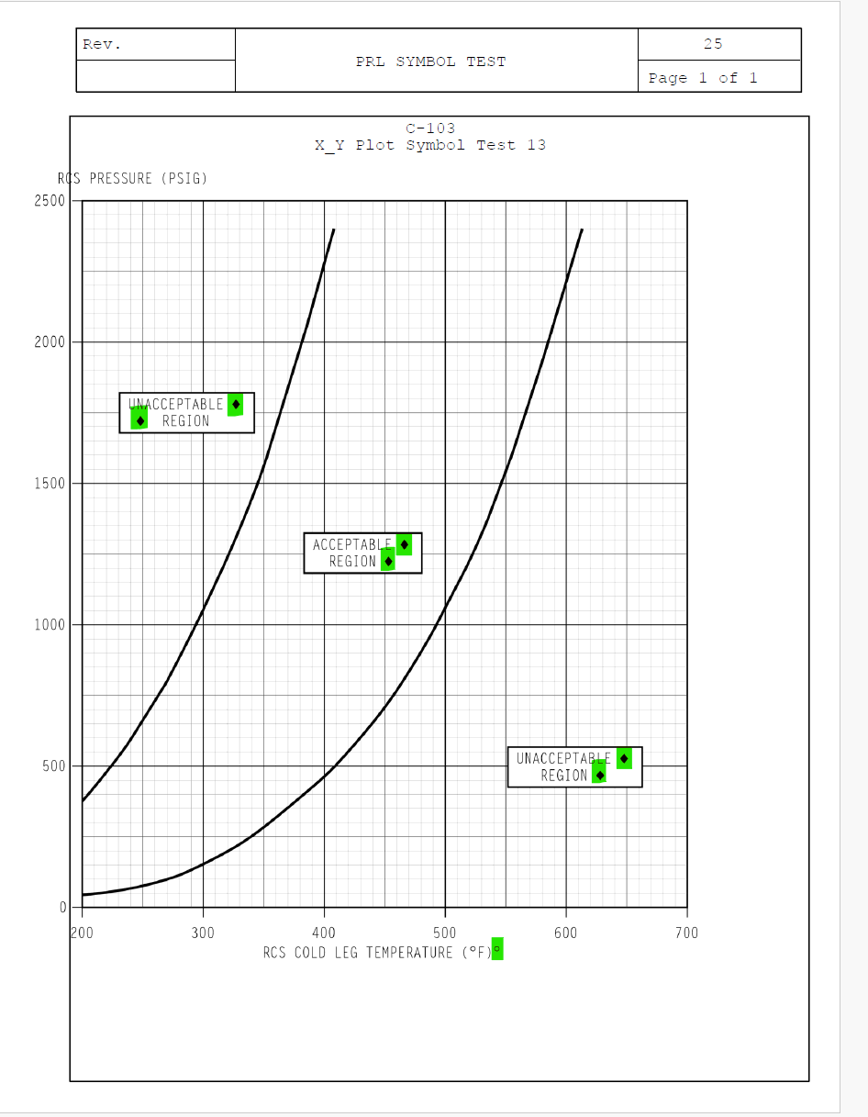

Changes/Additions to PROMS Manual and Training Videos:
[Do not use this section – for MRV/DMJ use]
- CSM submitted for PROMS User Manual: ____________.
- CSM submitted for training videos: ____________.

