July 30, 2025 (mrv updated)

Applicability: All plants

Internal Release Information:
C2025-027
Develop a way to filter annotations so the user can view only the types they want to see.

SQL updates included.

Generic External Release:
Users now can select a list of annotation types to display from the whole annotation types list. Each user can set up their own filtering from the V Button System Options.

Plant Specific Information for Release Letter:
N/A

Testing Requirements:
- USE DB VEPROMS_BWD
- Select Options in the V Button.
- Click Select in the “Select Annotation Types” frame.

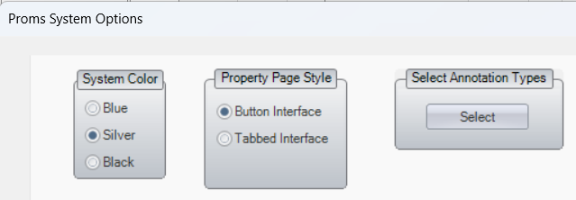

- In the Select Annotations Type frame, a list of existing annotation types for the database will display on the left side.

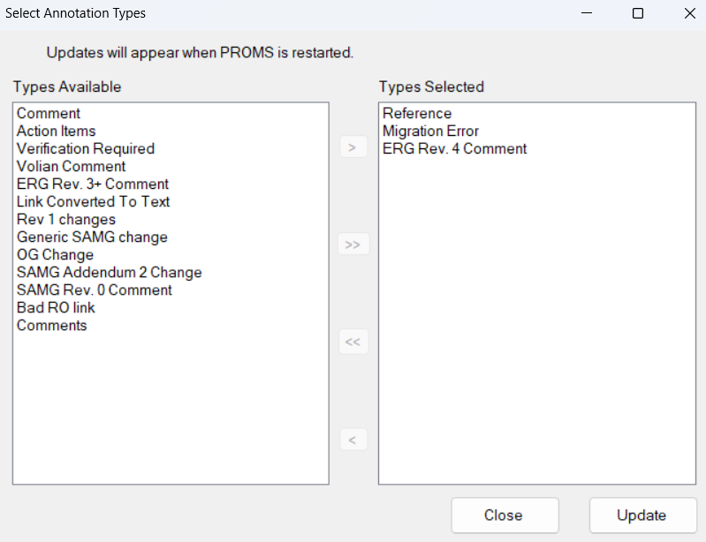
- Click on the double right arrow to move all items to the right side.
- Click on the double left arrow to move all items to the left side.
- Click on individual items on the left side, then click on the greater than arrow to add it to the right side.
- Click on an item in the right side, then click the less than arrow to move it back to the left side.
- Click Update. The window closes.
- Click Select in the “Select Annotation Types” frame.
- Verify the items selected in the right frame are still there.
- Click Close, then click OK to close the Options window.
- Close PROMS, then re-open PROMS.
- Go to a step with an annotation or expand the Annotation Details panel.
- Click in the “Type” drop-down menu and verify that the types that were added to the right column are the only ones that appear in the list.

Changes/Additions to PROMS Manual and Training Videos:
[Do not use this section – for MRV/DMJ use]
- CSM submitted for PROMS User Manual: ____________.
- CSM submitted for training videos: ____________.

