September 17, 2025

Applicability: Beaver Valley

Internal Release Information:
F2025-018
Added a new section “Attachment with Section Number and Title (w/ foldout) - Two Column” per customer request.

F2025-019
Removed format flag that would always uppercase setpoint units if in a high level step. This was done in all applicable Beaver Valley formats.

- [Check this box if a sql query or a data fix applies to this update].

Generic External Release:
N/A

Plant Specific Information for Release Letter:
Beaver Valley
- In all Beaver Valley format, setpoint unit text will no longer be forced to uppercase when a setpoint is in a high level step.
- In the Beaver Valley Two Column format, a new section type called “Attachment with Section Number and Title (w/ foldout) - Two Column” was added. This section type has column headings and will print the foldout on the back of the page.

Testing Requirements:
Use Beaver Valley data
- Update Formats
- Import the test procedure (ES-0.2) into the Unit 1 EOPs set. The file is located in the “V:\Proms Versions\Test Version\Data to use for testing\F2025-018 & F2025-019” folder
- Verify the section style name for the section “Attachment Sample Two Column” is set to “Attachment with Section Number and Title (w/ foldout) – Two Column”

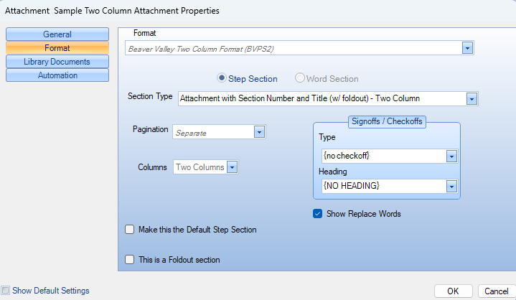

- Print the procedure.
- Verify the setpoint unit value in step 11 of the procedure steps section is not uppercased

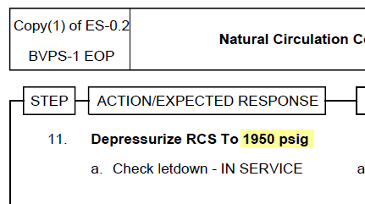

- Verify the new attachment section:
- Is numbered with the procedure
- Has the foldout on the back of the page
- Has the section number and title only on the first page
- Has the Issue number and Rev number in the page header

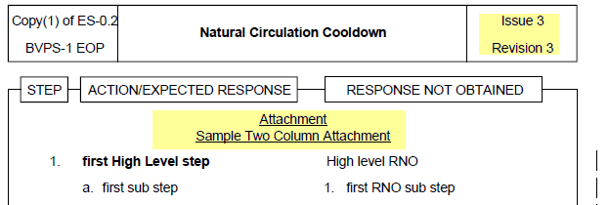

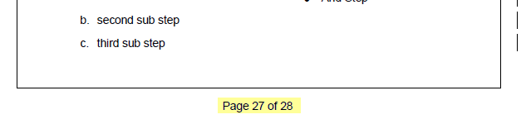

second page of attachment:

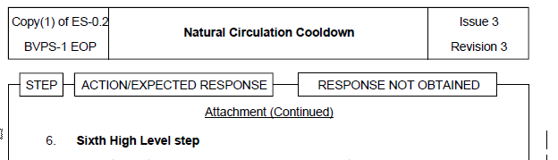

Changes/Additions to PROMS Manual and Training Videos:
[Do not use this section – for MRV/DMJ use]
- CSM submitted for PROMS User Manual: ____________.
- CSM submitted for training videos: ____________.

