5/8/2024

Applicability: B2024-026: Page Number transitions, duplicating page number

Internal Data Fixes: NA

Internal Release:

B2024-026: Page Number transitions, duplicating page number. This occurred when an error occurred when setting the Page Number Transitions and the user selected to run a second pass to determine if they may be fixed, i.e. the following dialog is displayed and user selects Yes.

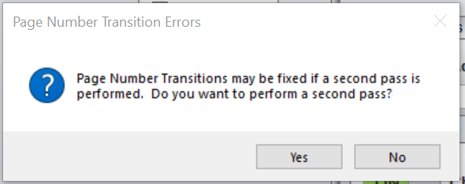

The code change made for F2024-048 introduced a hard space between ‘Page’ and the page number, this was done by inserting a Unicode hard space character defined as a Unicode \u160;, however the character to end the Unicode should have been a ‘?’, i.e. \u160?.

Generic External Release: NA

Plant Specific Information for Release Letter:

Robinson: When printing procedures with page number transitions, if there was an error when setting the page numbers in these transitions and the user selects to do a second pass to attempt to fix them, the page number transitions have a duplicate page number. This has been fixed.

Testing Performed:

See Testing Required.

Testing Requirements:

Using DC Cook sql database:
£ Print AOP Unit 1 016-001 and when the Page Number Transition Errors dialog appears, select Yes. Verify that Step 1 RNOa and Step 13 RNO do not have page numbers in the transition printed twice:

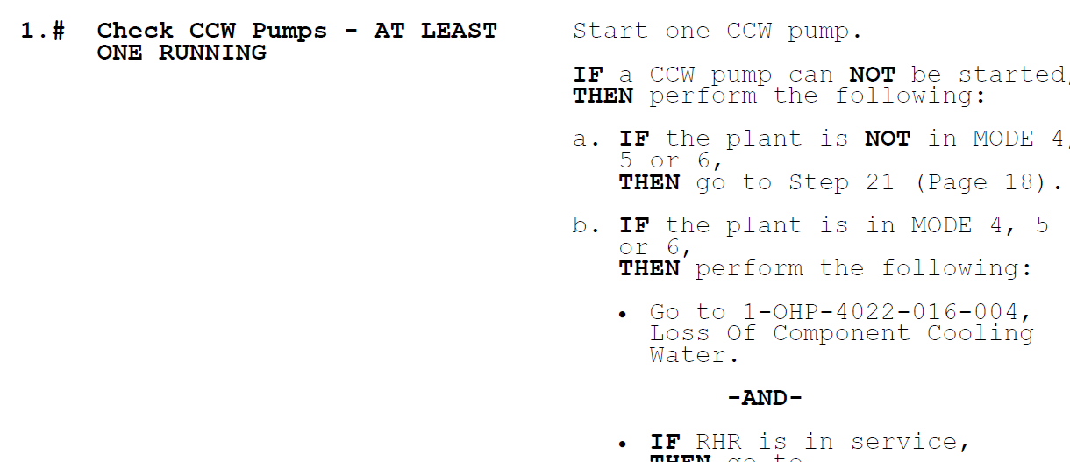
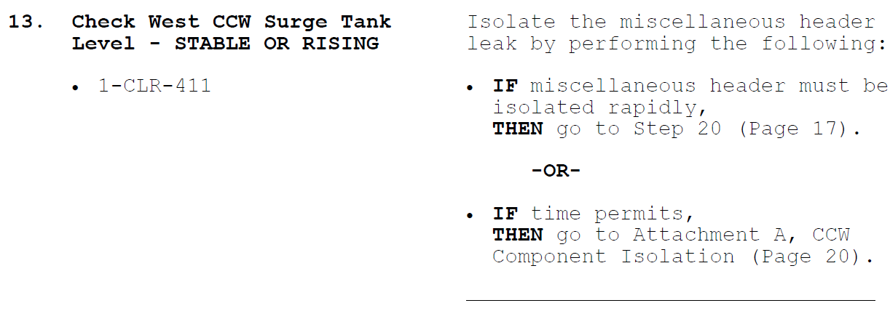

Test previous F2024-048:
Using Robinson sql database:
£ Open EOP EPP-28 (the last procedurein the set) in the HB Robinson (UPGRADE) – Emergency Operating Procedures 2+ procedure set
£ Add an unnumbered high level step to the Purpose and Entry Conditions section (don’t add text)
£ Add the {Section Number} {Section Title}{Page Num} transition (second to last transitoin type), selecting Attachment 2 and selecting the check box to include the page number.
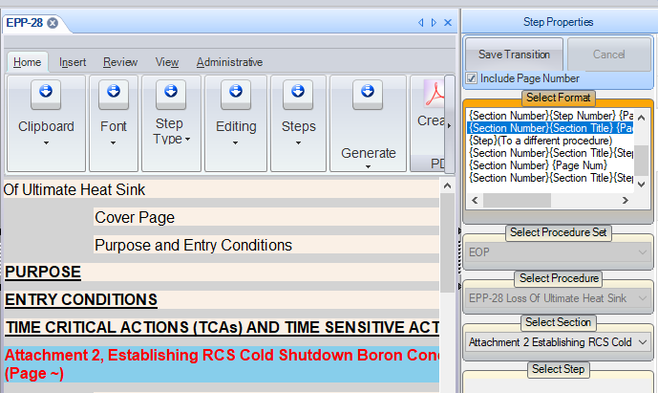

£ Print the procedure and verify the page number text for that transition wraps to the next line.
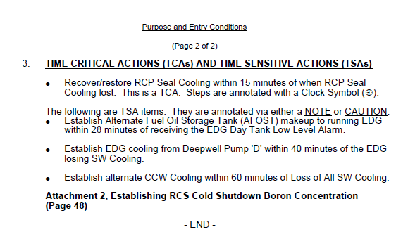

Changes/Additions to User Documentation: NA

