June 12, 2026

Applicability: VOG3_4

Internal Release Information:

B2026-058 – If approving multiple procedures at the same time with a multiunit set and one of the procedures is open, PROMS sometimes loses that it is set for an individual unit.

Use Vogtle data, open procedure
ARPs -> Main Control Room -> MSS -> MSS-ARP-001 - 001

Approve for unit 3, select procedures:
MSS-ARP-001 - 001, MSS-ARP-001 - 002, MSS-ARP-001 - 003, MSS-ARP-001 - 004
with Revision Number 1.0

After finished, approve same procedures, same Rev Number for Unit 4

Sean Michael at Vogtle reported having the same issue with the HDS ARPs set.

- [Check this box if a sql query or a data fix applies to this update].

Generic External Release:
When approving multiple multi-unit procedures at the same time, PROMS will now take the selected unit into account when checking for duplicate revision numbers.

Plant Specific Information for Release Letter:
Requested by Sean Michael at Vogtle - When approving multiple multi-unit procedures at the same time, PROMS will now take the selected unit into account when checking for duplicate revision numbers.

Testing Requirements:
- Use Vogtle Data
- open procedure
ARPs -> Main Control Room -> MSS -> MSS-ARP-001 - 001
- Approve for unit 3, select procedures:
MSS-ARP-001 - 001, MSS-ARP-001 - 002, MSS-ARP-001 - 003, MSS-ARP-001 - 004
with Revision Number 1.0
- After approval has finished, approve the same procedures, same Rev Number for Unit 4
- Should not receive prompt to replace existing Revision
- Open HDS-ARP-001
- Approve all procedures at the same time for Unit 3 with Revision Number 1.0
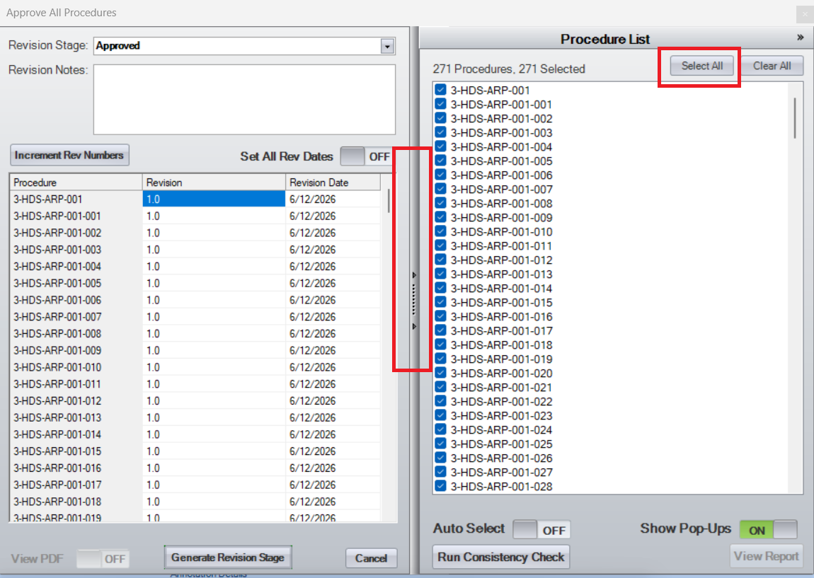
- After approval has finished, approve the same procedures, same Rev Number for Unit 4
- Should not receive prompt to replace existing Revision

Changes/Additions to PROMS Manual and Training Videos:
[Do not use this section – for MRV/DMJ use]
- CSM submitted for PROMS User Manual: ____________.
- CSM submitted for training videos: ____________.

