Sept 10, 2026

Applicability: All

Internal Release Information:
C2026-048 Tool Tip Update for “Find Unlinked Values of Selected” checkbox on “Reference Objects” tab in the Search tools.

- [Check this box if a sql query or a data fix applies to this update].

Generic External Release: The tooltip in the Search|Referenced Object tab now accurately reflects the title “Find Unlinked Values”.

Plant Specific Information for Release Letter: N/A

Testing Requirements:
- Use Any DB.
- Open a procedure.
- Select a step level that gives you access to Search Tools.
- In Search tools select Reference Objects tab.
- In the drop down below the tab name select an option that activates the checkbox “Find Unlinked Values of Selected”.
- Hover over the checkbox name.
- Verify that the title of the tool tip title is correct.

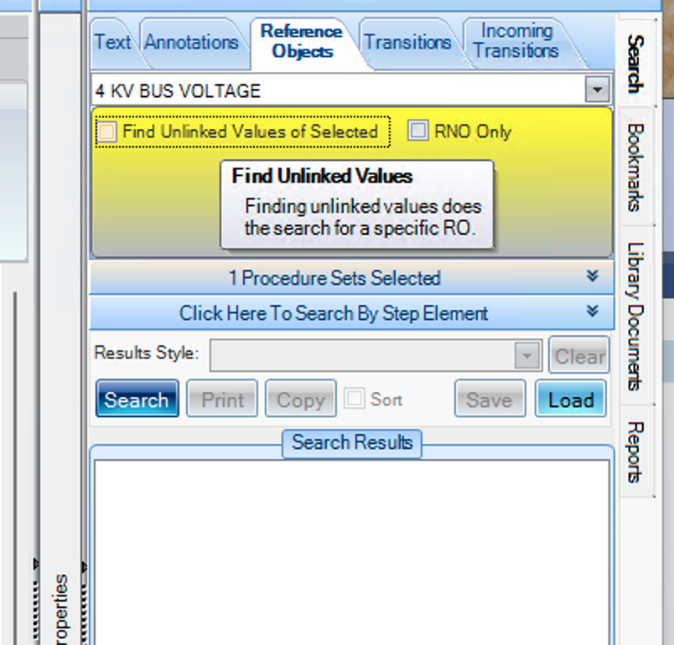

Changes/Additions to PROMS Manual and Training Videos:
[Do not use this section – for MRV/DMJ use]
- CSM submitted for PROMS User Manual: ____________.
- CSM submitted for training videos: ____________.

