September 11, 2024

Applicability: All Plants

Internal Release Information:
B2024-068
B2024-069
Check if current annotation is not selected before removal of annotation.

If annotation was not selected, prompted user with message box to select an annotation before selecting the remove option.

- [Check this box if a sql query or a data fix applies to this update].

Generic External Release:
PROMS will now prompt a user if an attempt is made to remove an annotation when a specific annotation is not selected.

Plant Specific Information for Release Letter:
N/A

Testing Requirements:
- Use any plants database
- Select a Procedure and select the Annotation Details
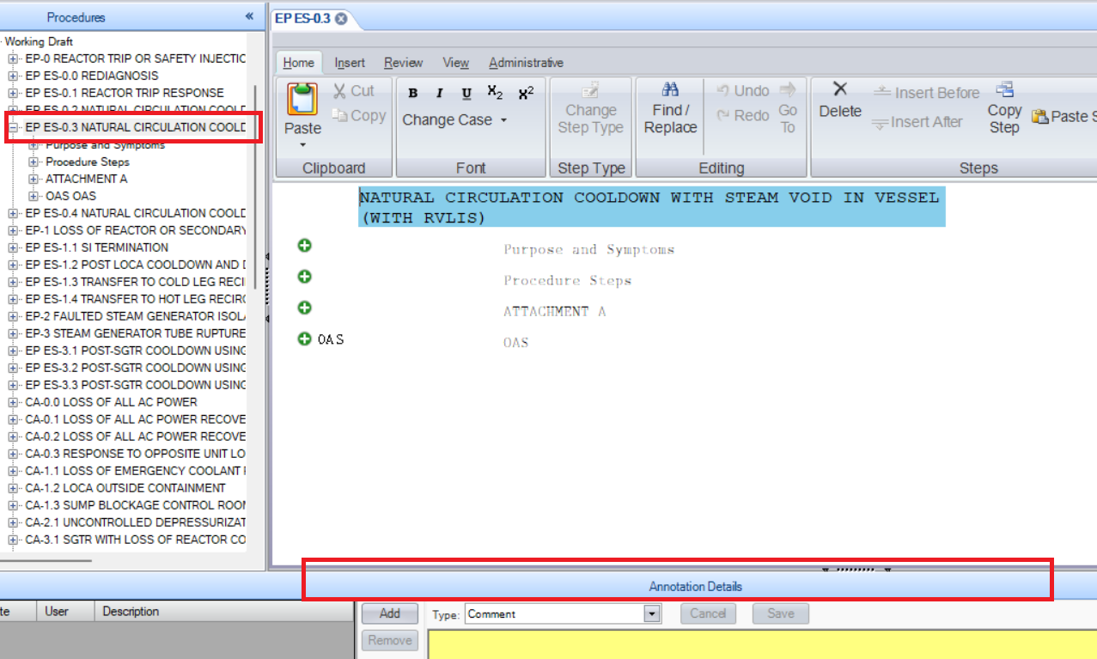

- Enter Comment Text then click Save, and then Add
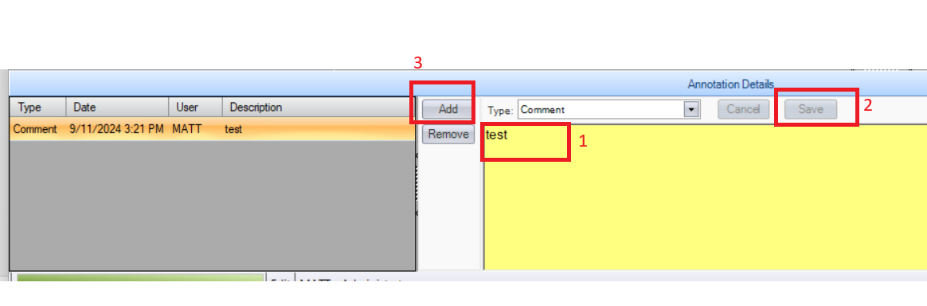
- Select Remove
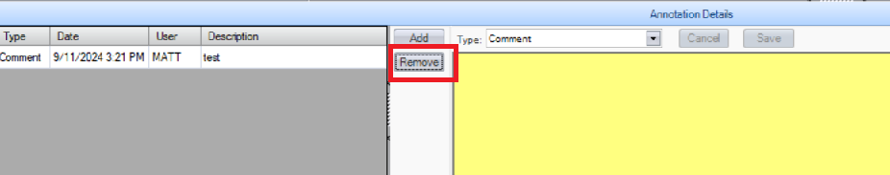

- Verify Dialog Box Prompting User for Annotation Selection
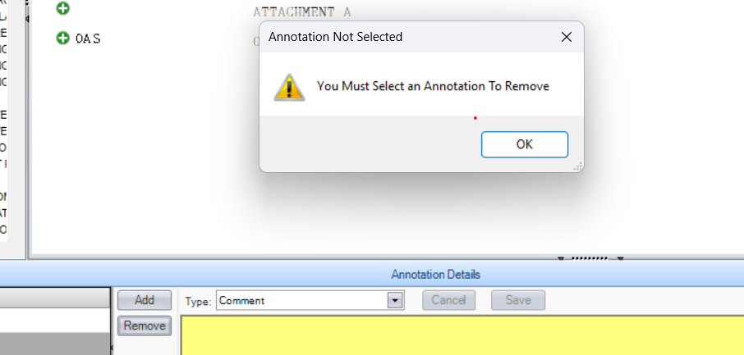

Changes/Additions to PROMS Manual and Training Videos:
[Do not use this section – for MRV/DMJ use]
- CSM submitted for PROMS User Manual: ____________.
- CSM submitted for training videos: ____________.

