November 11, 2024

Applicability: South Texas

Internal Release Information:
B2024-092 Add Initial Line/Ability to Disable to UI for South Texas

When running the baselines for the South Texas Formats (OHLP, HLP, HLPFSG) related to CSM F2024-080 (turn on initial line), Lydia came across shifting of some items in the printing. After review, an inconsistency was discovered in Print when the MacroEditTag was used. (it was displaying text without the MacroEditTag (as it should) but it was using text with the MacroEditTag to determine positioning in the PDF)

In addition, need to change the width on the columns on the (hlpfsgall) South Texas FSG Format. The addition of the checkoff line to RNOs was causing the 1st column to overlap with the checkoff line.

- [Check this box if a sql query or a data fix applies to this update].

Generic External Release:
N/A

Plant Specific Information for Release Letter:
South Texas formats (OHLP, HLP, HLPFSG)). Turn on the initial line for all sub-steps and include turning it on in the RNO column. Add ability to disable the initial line for steps/sub-steps in the UI. Changing Column width of South Texas FSG Format to prevent overlap.

Testing Requirements:
- Use South Texas data – choose a procedure using HLPFSG Format with RNOs (like 0POP12-ZO-FSG04 for example)
- Printing the Procedure should result in spacing around step tabs similar to prior to CSM F2024-080 (there should not be spaces between the checkoff line and step numbers and spacing between step numbers and step text should be the same)
- Column widths have changed, so should not be overlap between 1st column and checkoff lines in RNO column.
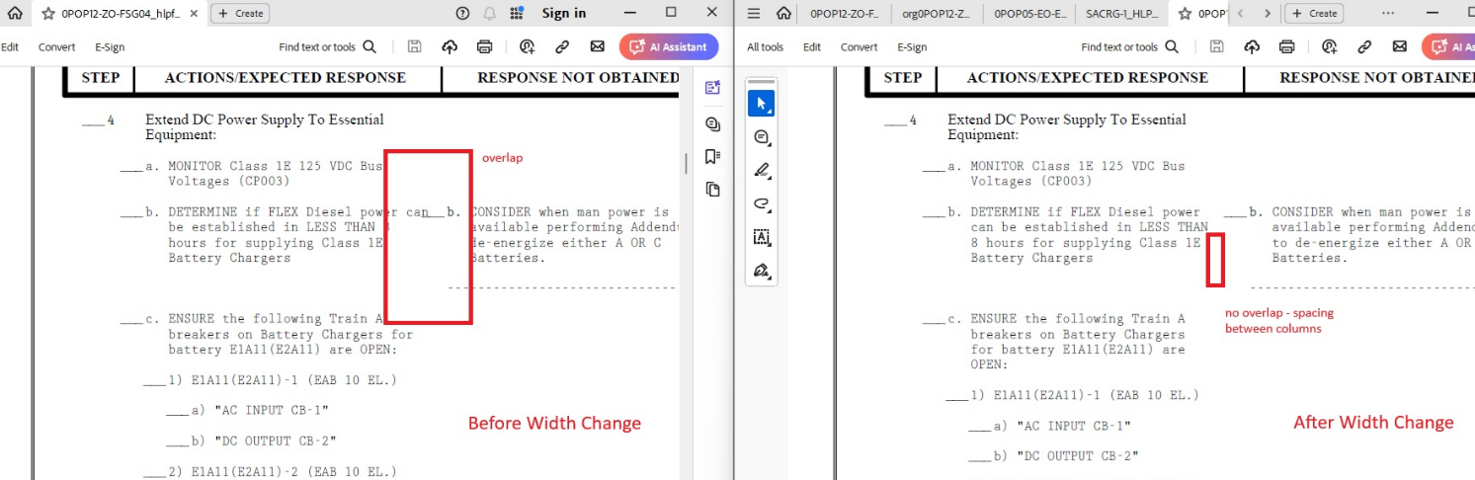

Changes/Additions to PROMS Manual and Training Videos:
[Do not use this section – for MRV/DMJ use]
- CSM submitted for PROMS User Manual: ____________.
- CSM submitted for training videos: ____________.

