Library Documents – User Interface
July 2008

- View Library Documents, i.e. search.
On User Interface, ‘Search Panel’ has tab for library documents. Upon tab select, a list of library documents is shown this includes a count of usages. If one is selected with no usages, allow delete. If one is selected with usages, a list of usages is shown.
- Word Document Maintenance
When Word Document is selected in tree view (Use properties dialog on section from tree view to get the dialog):
- If it has existing data, can either convert section to a library document or use a library document. If library document is used, warn user that data will be lost.
- If no existing data, no convert button is displayed.
- If it is tied to a library document, then Convert Button becomes ‘Convert this Section To a Non-Library Document’.
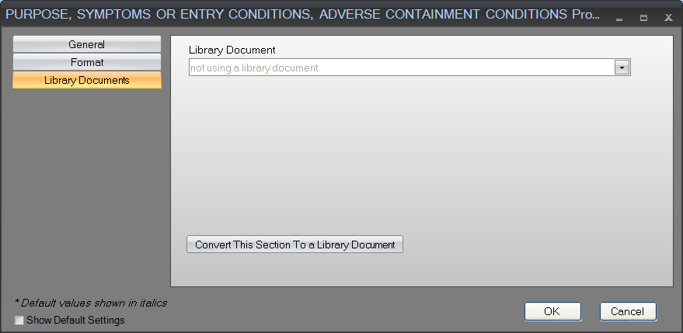
- Edit Content
Edit occurs directly from user interface. After edit, dialog box is given to ask user whether update is for all usages (keep as library document) or just this one (save as non-library document).
- Library Document specific to procedure sets or used throughout database

