Updating DotNetBar
Notes:
- Currently dotnetbar is 2.0 not 4.6
- Powershell:
$path = "C:\Git\Production\3rdPartyLibraries\DotNetBar\DotNetBar4.6Build\DevComponents.DotNetBar2.dll"
[Reflection.Assembly]::ReflectionOnlyLoadFrom($path).ImageRuntimeVersion
[Reflection.Assembly]::LoadFrom($path).ImageRuntimeVersion
- 2.0 assemblies copy under C:\Windows\assembly\GAC_MSIL
4x+ do not – they copy to C:\Windows\Microsoft.NET\assembly\GAC_MSIL
- Can get dlls to compile load forms in Visual Studio. Interactive controls do not work in Designer
- Since recompiling will mean losing the interactive nature of the controls in the Visual Studio designer and also we have no way of knowing what we may be missing from DotNetBar --- at this point, we are not recompiling / staying with the .Net 2.0 version --- note that these are stored in the .Net 4.6 build folders as this is where PROMS is set to pull from for compiling.

Compiling dotnetbar DLL:
- Open solution
C:\Git\Production\Repos\SourceCode\PROMS\DotNetBar Source Code\DotNetBarBuild.sln
- Set Target Framework, keep Assembly Version as 14.1.0.37, increment file version by one
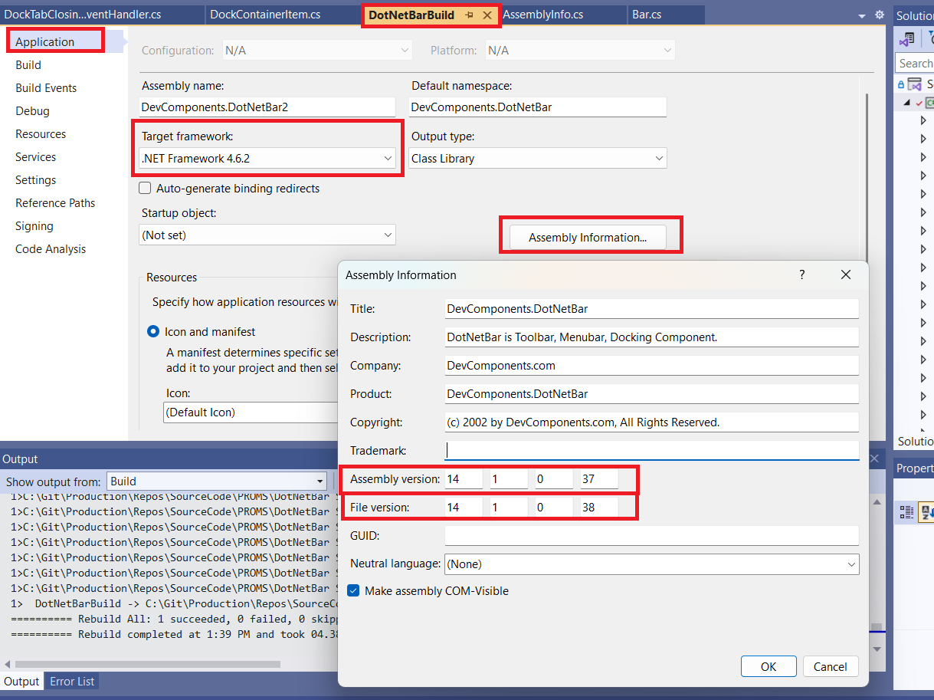
- Sign the Assembly. Used same pwd as zip files (if do not sign, cannot add dll to the GAC)
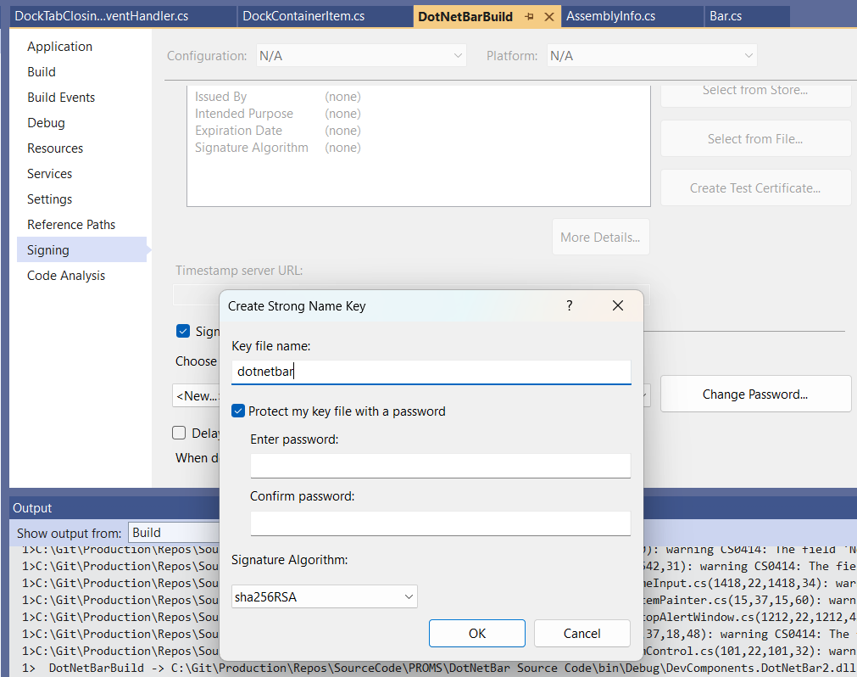
- Save project and compile – be sure to build in Release Mode instead of Debug (otherwise navigation will not work in toolbox)
- Copy dll from
C:\Git\Production\Repos\SourceCode\PROMS\DotNetBar Source Code\bin\Debug\DevComponents.DotNetBar2.dll
To
C:\Git\Production\3rdPartyLibraries\DotNetBar\DotNetBar4.6Build
Compiling dotnetbar.Schedule DLL:
- Open solution
C:\Git\Production\Repos\SourceCode\PROMS\DotNetBar Source Code\DotNetBarBuild.sln
- Perform same actions / use same file to sign
Compiling dotnetbar.Design.DLL:
- Open solution
C:\Git\Production\Repos\SourceCode\PROMS\DotNetBar Source Code\ DotNetBarDesignTime\DotNetBarDesignTime.csproj
- Perform same actions / use same file to sign
- Note – may need to refresh references to dotnetbar2.dll & dotnetbar.schedule.dll
Compiling dotnetbar.Layout.DLL:
- Open project
C:\Git\Production\Repos\SourceCode\PROMS\DotNetBar Source Code\DevComponents.DotNetBar.Layout\ DevComponents.DotNetBar.Layout.csproj
- Perform same actions / use same file to sign
- Note – may need to refresh references to dotnetbar2.dll
Compiling dotnetbar.Layout.Design.DLL:
- Open solution
C:\Git\Production\Repos\SourceCode\PROMS\DotNetBar Source Code\ DotNetBarDesignTime\DotNetBarDesignTime.csproj
- Perform same actions / use same file to sign
- Note – may need to refresh references to dotnetbar2.dll & dotnetbar.Layout.dll
Compiling Instrumentation.DLL:
- Open solution
C:\Git\Production\Repos\SourceCode\PROMS\DotNetBar Source Code\InstrumentationControls\DevComponents.Instrumentation.csproj
- Perform same actions / use same file to sign
Compiling Instrumentation.Design.DLL:
- Open solution
C:\Git\Production\Repos\SourceCode\PROMS\DotNetBar Source Code\InstrumentationControls\KnobControlDesignTime\ InstrumentationDesignTime.csproj
- Perform same actions / use same file to sign
Compiling dotnetbar.SuperGrid.DLL:
- Open solution
C:\Git\Production\Repos\SourceCode\PROMS\DotNetBar Source Code\DevComponents.DotNetBar.SuperGrid\ SuperGrid.csproj
- Perform same actions / use same file to sign
- Note – may need to refresh references to dotnetbar2.dll & dotnetbar.Instrumentation.dll
Compiling dotnetbar.SuperGrid.Design.DLL:
- Open solution
C:\Git\Production\Repos\SourceCode\PROMS\DotNetBar Source Code\DevComponents.SuperGrid.Design\ SuperGridDesignTime.csproj
- Perform same actions / use same file to sign
- Note – may need to refresh references to dotnetbar2.dll & dotnetbar.Layout.dll
Compiling dotnetbar.Charts.DLL:
- Open project
C:\Git\Production\Repos\SourceCode\PROMS\DotNetBar Source Code\DevComponents.DotNetBar.Charts\ DevComponents.DotNetBar.Charts.csproj
- Perform same actions / use same file to sign
- Note – may need to refresh references to dotnetbar2.dll
Compiling dotnetbar.Charts.Design.DLL:
- Open solution
C:\Git\Production\Repos\SourceCode\PROMS\DotNetBar Source Code\DevComponents.DotNetBar.Charts.Design\ DevComponents.DotNetBar.Charts.Design.csproj
- Perform same actions / use same file to sign
- Note – may need to refresh references to dotnetbar2.dll & dotnetbar.Charts.dll
Compiling dotnetbar.TreeGX.DLL:
- Open solution
C:\Git\Production\Repos\SourceCode\PROMS\DotNetBar Source Code\TreeGX\ TreeGX.csproj
- Perform same actions / this one doesn’t need signed
Compiling dotnetbar.Keyboard.DLL:
- Open solution
C:\Git\Production\Repos\SourceCode\PROMS\DotNetBar Source Code\DevComponents.DotNetBar.Keyboard\DevComponents.DotNetBar.Keyboard.csproj
- Perform same actions / use same file to sign

Updating so can view in VS Designer:
- Close all Visual Studio instances

- Add or Remove Programs
Remove: DotNetBar for Windows Forms

- Open Developer Command Prompt for VS2022 – run as Admin

- cd to assembly location
cd C:\Git\Production\3rdPartyLibraries\DotNetBar\DotNetBar4.6Build
- gacutil /i DevComponents.DotNetBar2.dll
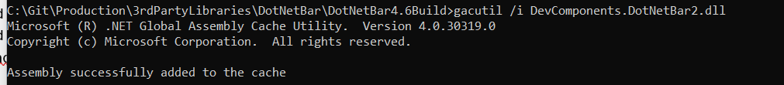
- gacutil /i DevComponents.DotNetBar.Design.dll
- gacutil /i DevComponents.Charts.Design.dll
- gacutil /i DevComponents.DotNetBar.Charts.dll
- gacutil /i DevComponents.DotNetBar.Keyboard.dll
- gacutil /i DevComponents.DotNetBar.Layout.Design.dll
- gacutil /i DevComponents.DotNetBar.Layout.dll
- gacutil /i DevComponents.DotNetBar.Schedule.dll
- gacutil /i DevComponents.DotNetBar.SuperGrid.dll
- gacutil /i DevComponents.Instrumentation.Design.dll
- gacutil /i DevComponents.Instrumentation.dll
- gacutil /i DevComponents.SuperGrid.Design.dll
- gacutil /i DevComponents.TreeGX.dll
Updating so don’t get “Invalid License” in VS Designer:
- Close all Visual Studio instances

- Copy all dlls from: C:\Git\Production\3rdPartyLibraries\DotNetBar\DotNetBar4.6Build
To:
C:\Program Files (x86)\DotNetBar for Windows Forms\Signed

For Future – if need to update DotnetBar dll:
- Close all Visual Studio instances
- Make sure new dll is in: C:\Git\Production\3rdPartyLibraries\DotNetBar\DotNetBar4.6Build
- Open Developer Command Prompt for VS2022 – run as Admin
- cd to assembly location
cd C:\Git\Production\3rdPartyLibraries\DotNetBar\DotNetBar4.6Build
- Remove from MSIL with: gacutil /u DevComponents.DotNetBar2
- gacutil /i DevComponents.DotNetBar2.dll

Test can use in Designer:
- Open Visual Studio VEPROMS project
- Rebuild Solution
- Verify date of DevComponents.DotNetBar2dll in C:\Git\Production\Repos\SourceCode\PROMS\VEPROMS User Interface\bin\Debug
- Verify can open “frmBatchRefresh” and “dlgPrintAllApprovedProcedures” in VS Designer and can swap menu items in “frmBatchRefresh” in Designer

Add to VS Toolbox:
- Open Visual Studio VEPROMS project
- In Toolbox, right click and select Add Tab --- name it DotnetBar
- Right click on the new tab and select Choose Items
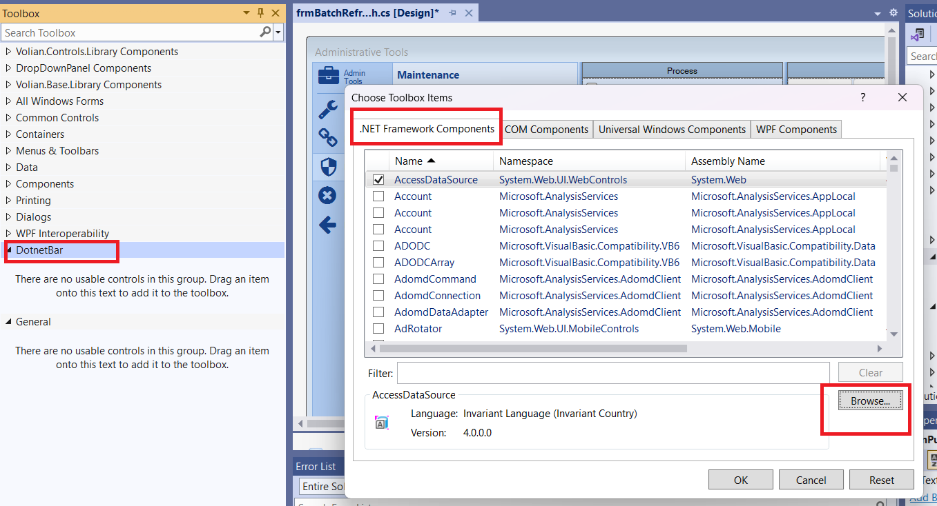
- Browse and select the 3 dlls below in C:\Git\Production\3rdPartyLibraries\DotNetBar\DotNetBar4.6Build
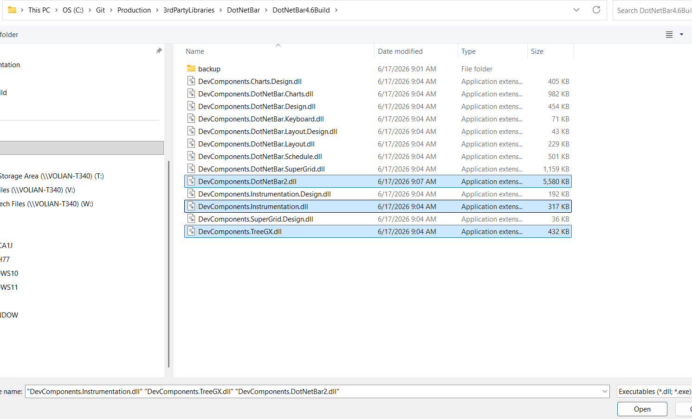
- Verify controls show in toolbox when a form is open in the designer

Final Steps:
- Test
- Check in changes

